JOG Science Faculty Revision Support

Chemistry PAPER 2 Quick Quiz Sheets

CONTENT
- (C6) The rate and extent of chemical change

- (C7) Organic chemistry

- (C8) Chemical analysis

- (C9) Atmosphere

- (C10) Using energy resources

Parents and guardians frequently inquire about how they can support their children in preparing for their science exams. Quick quiz sheets offer an opportunity for parental involvement in the revision journey. These sheets contain crucial information essential for success in the GCSE science exams, allowing families to memorise important facts together. Additionally, personalised learning checklists are provided for each module, enabling students to track their progress effectively.

C6 (the rate and extent of chemical change PAPER 2)
QUICK QUIZ QUESTIONS
Spec |  | QUESTION | ANSWER | TICK
4.6.1 | 1 | What is the equation for working out the rate of a reaction in terms of the reactant used? | 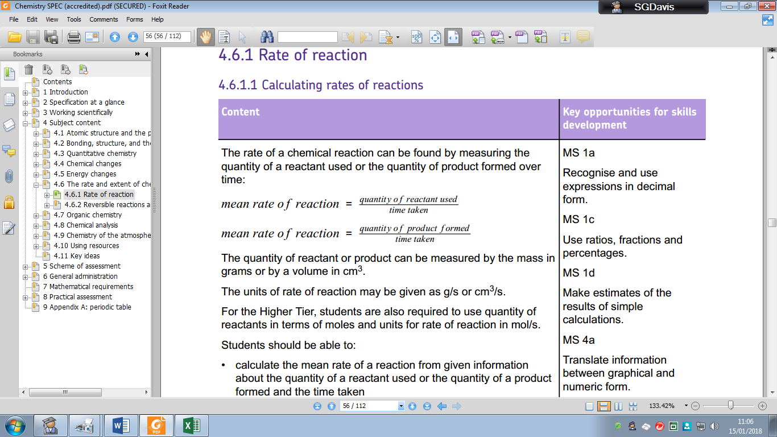
4.6.1 | 2 | What is the equation for working out the rate of a reaction based on the product formed?
4.6.1 | 3 | How are quantities measured in chemistry? | Mass in grams or by a volume in cm^{3.}
4.6.1 | 4 | What are the units for rate of reaction? | g/s (grams per second) or cm³/s (centimetre cubed per second).
4.6.1 | 5 | What does collision theory explain? | How various factors affect rates of reactions.
4.6.1 | 6 | What is needed for a chemical reaction to occur? | Particles colliding with each other and with sufficient energy.
4.6.1 | 7 | What is the activation energy? | The minimum amount of energy that particles  must have to react.
4.6.1 | 8 | What are the 4 main ways to increase the rate of reaction (without adding any chemicals additionally) | - Increasing the concentration of reactants in solution  - Increasing the pressure of reacting gases  - Increasing the surface area of solid reactants  - increasing the temperature
4.6.1 | 9 | How does changing the temperature increase the rate of a chemical reaction? | Increases the frequency of collisions and makes the collisions more energetic.
4.6.1 | 10 | What is a catalyst? | Catalysts change the rate of chemical reactions but are not used up during the reaction.
4.6.1 | 11 | How are enzymes like catalysts? | Enzymes act as catalysts in biological systems.
4.6.1 | 12 | How do catalysts increase the rate of a chemical reaction? | Increase the rate of reaction by providing a different pathway for the reaction that has a lower activation energy.
4.6.1 | 13 | Draw a reaction profile diagram for a reaction that has been given a catalyst | 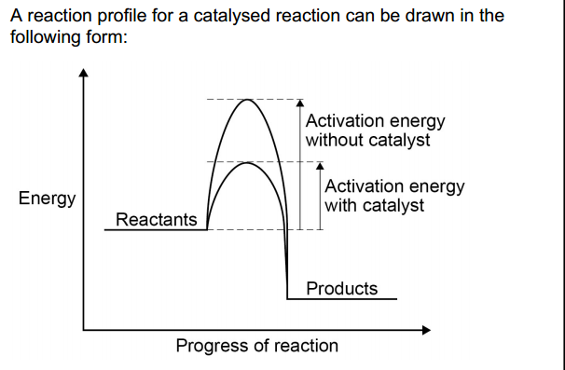
4.6.2 | 14 | What are reversible reactions, how are they written down? | The products of the reaction can react to produce the original reactants  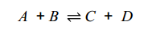
4.6.2 | 15 | What is an exothermic reaction? | A reaction where thermal energy is released into the surroundings.
4.6.2 | 16 | What is an endothermic reaction? | A reaction where thermal energy is removed from the surroundings.
4.6.2 | 17 | If a reaction is exothermic in one direction, what can be said about the reaction in the reverse direction? | If a reversible reaction is exothermic in one direction, it is endothermic in the opposite direction.
4.6.2 | 18 | What does equilibrium mean when referring to a reversible reaction? | Forward and reverse reactions occur at exactly the same rate.
4.6.2 | 19 | Higher ONLY  What is the name of the principle used to predict the effects of changing the conditions on equilibrium? | Le Chatelier’s Principle.
4.6.2 | 20 | Higher ONLY  In simple terms what is Le Chatelier’s Principle? | If a system is at equilibrium and a change is made to any of the conditions, then the system responds to counteract the change.
4.6.2 | 21 | Higher ONLY  What does Le Chatelier’s Principles say about changing concentrations in a reaction? | If the concentration of one of the reactants or products is changed, the system is no longer at equilibrium and the concentrations of all the substances will change until equilibrium is reached again.
4.6.2 | 22 | Higher ONLY  What does Le Chatelier’s Principles say about decreasing concentrations in a reaction? | If the concentration of a product is decreased, more reactants will act until equilibrium is reached again.
4.6.2 | 23 | Higher ONLY  What does Le Chatelier’s Principles say about increasing the temperature in a reaction? | The relative amount of products at equilibrium increases for an endothermic reaction.  The relative amount of products at equilibrium decreases for an exothermic reaction.
4.6.2 | 24 | Higher ONLY  What does Le Chatelier’s Principles say about decreasing the temperature in a reaction? | The relative amount of products at equilibrium decreases for an endothermic reaction.  The relative amount of products at equilibrium increases for an exothermic reaction.
4.6.2 | 25 | Higher ONLY  What does Le Chatelier’s Principles say about increasing the pressure in a reaction? | An increase in pressure causes the equilibrium position to shift towards the side with the smaller number of molecules as shown by the symbol equation for that reaction.
4.6.2 | 26 | Higher ONLY  What does Le Chatelier's Principle say about decreasing the pressure in a reaction? | A decrease in pressure causes the equilibrium position to shift towards the side with the larger number of molecules as shown by the symbol equation for that reaction.

C7 Organic chemistry (PAPER 2)
QUICK QUIZ QUESTIONS
Spec |  | QUESTION | ANSWER | TICK
4.7.1 | 1 | Where is crude oil found? | In rocks.
4.7.1 | 2 | What is crude oil? | Ancient biomass consisting mainly of plankton that was buried in mud.
4.7.1 | 3 | What are the most common elements found in crude oil? | Hydrogen and carbon atoms.
4.7.1 | 4 | What are the most common hydrocarbons found in oil? | Most of the hydrocarbons in crude oil are hydrocarbons called alkanes.
4.7.1 | 5 | What is the general formula for working out the number of hydrogen and carbon atoms in an alkane? | C₂H_{2n+2}
4.7.1 | 6 | Name the first 4 members of the alkane family | Methane, ethane, propane and butane.
4.7.1 | 7 | What is the name of the process where crude oil is separated into fractions? | Fractional distillation.
4.7.1 | 8 | How does fractional distillation work? | The many hydrocarbons in crude oil may be separated into fractions, each of which contains molecules with a similar number of carbon atoms.
4.7.1 | 9 | What do the fractions get used for? | Fuels and feedstock.
4.7.1 | 10 | What are the names of the fractions? | Petrol, diesel oil, kerosene, heavy fuel oil and liquefied petroleum gases.
4.7.1 | 11 | Name some useful chemicals produced by the petrol chemistry industry | Solvents, lubricants, polymers, detergents.
4.7.1 | 12 | What do the properties of hydrocarbon compounds depend on? | The size of their molecules.
4.7.1 | 13 | Name some properties of hydrocarbons that depend on the size of the molecules | Boiling point, viscosity and flammability.
4.7.1 | 14 | What is released when you combust hydrocarbon fuels? | Energy.
4.7.1 | 15 | What happens chemically to hydrogen and carbon during combustion? | Oxidation (they become oxidised).
4.7.1 | 16 | What are the products of complete combustion of a hydrocarbon fuel? | Carbon dioxide and water.
4.7.1 | 17 | What is the name of the process when hydrocarbons are broken down? | Cracking.
4.7.1 | 18 | What are the names of the methods that achieve cracking? | Catalytic cracking and steam cracking.
4.7.1 | 19 | What types of hydrocarbons are produced during cracking? | Alkanes and alkenes.
4.7.1 | 20 | What is the test for alkenes? | Bromine water.
4.7.1 | 21 | What are the uses of small molecules produced from cracking? | Fuels.
4.7.1 | 22 | What are alkenes used to produce? | Polymers.

C8 Chemical analysis (PAPER 2)
QUICK QUIZ QUESTIONS
Spec |  | QUESTION | ANSWER | TICK
4.8.1 | 1 | What is a ‘pure substance’? | A single element or compound not mixed with any other substance.
4.8.1 | 2 | What is the relationship between the melting points and boiling points of elements and compounds that are said to be pure? | Melting and boiling occur at specific temperatures.
4.8.1 | 3 | What can melting and boiling points be used for in analysis? | To distinguish pure substances from mixtures.
4.8.1 | 4 | What is a formulation? | A mixture that has been designed as a useful product.
4.8.1 | 5 | How are formulations made? | By mixing the components in carefully measured quantities to ensure that the product has the required properties.
4.8.1 | 6 | Name some common formulations | Fuels, cleaning agents, paints, medicines, alloys, fertilisers and foods.
4.8.1 | 7 | What is chromatography used for? | Chromatography can be used to separate mixtures and can give information to help identify substances.
4.8.1 | 8 | Chromatography involves 2 ‘phases’ that we measure. What are the names of the two phases? | Stationary phase and a mobile phase.
4.8.1 | 9 | What does the separation of a substance depend on during chromatography? | Separation depends on the distribution of substances between the phases.
4.8.1 | 10 | What is the equation for working out R_{f} value? | 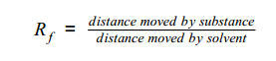
4.8.1 | 11 | What do R_{f} values do? | Different compounds have different Rf values which can be used to help identify the compounds in a mixture.
4.8.1 | 12 | How does chromatography tell you the difference between a pure substance and a mixture? | The compounds in a mixture may separate into different spots depending on the solvent but a pure compound will produce a single spot in all solvents.
4.8.2 | 13 | What is the test for hydrogen gas? | A burning splint held at the open end of a test tube of the gas.
4.8.2 | 14 | What is a positive result for hydrogen during the squeaky pop test? | Hydrogen burns rapidly with a pop sound (squeaky pop test).
4.8.2 | 15 | What is the test for oxygen? | The test for oxygen uses a glowing splint inserted into a test tube of the gas.
4.8.2 | 16 | What is a positive result for oxygen during the test? | The splint relights in oxygen.
4.8.2 | 17 | What is the test for carbon dioxide? | Calcium hydroxide (lime water).
4.8.2 | 18 | What is a positive result in the test for carbon dioxide? | Limewater turns milky (cloudy).
4.8.2 | 19 | What is the test for chlorine? | Litmus paper.
4.8.2 | 20 | What is the positive result for chlorine? | The litmus paper is bleached and turns white.

C9 Chemistry of the atmosphere
Spec |  | QUESTION | ANSWER | TICK
4.9.1 | 1 | What proportions of the atmosphere are nitrogen, oxygen and other gases? | 79% Nitrogen  20% Oxygen  1% Carbon dioxide, water vapour and noble gases.
4.9.1 | 2 | Why are scientists not always confident about the composition of the atmosphere from millions of years ago compared with now? | Theories about what was in the Earth’s early atmosphere and how the atmosphere was formed have changed and developed over time.
4.9.1 | 3 | What sort of time scale covers the development of our atmosphere? | 4.6 billion years.
4.9.1 | 4 | How do scientists describe the atmosphere in the first billion years? | There was intense volcanic activity that released gases that formed the early atmosphere and water vapour that condensed to form the oceans.
4.9.1 | 5 | What planets do scientists often compare to the Earth's early atmosphere too? | Mars and Venus today, consisting mainly of carbon dioxide with little or no oxygen gas.
4.9.1 | 6 | What gases did the volcanoes release into the atmosphere in the first 1 billion years? | Volcanoes produced nitrogen which gradually built up in the atmosphere and there may have been small proportions of methane and ammonia.
4.9.1 | 7 | What did the presence of oceans do to the early atmosphere? | When the oceans formed carbon dioxide dissolved in the water.
4.9.1 | 8 | What formed from the carbon dioxide dissolved into the water? | Sediment.
4.9.1 | 9 | Where did the oxygen come from that is now in our atmosphere? | Algae and plants (through photosynthesis).
4.9.1 | 10 | What is the chemical formula that describes how oxygen was produced (the photosynthesis equation)? | 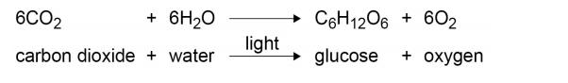
4.9.1 | 11 | When did algae first produce oxygen? | 2.7 billion years ago.
4.9.1 | 12 | What happened for the next billion years after algae first appeared? | Plants evolved and the percentage of oxygen gradually increased to a level that enabled animals to evolve.
4.9.1 | 13 | What other process led to the decrease of carbon dioxide in the atmosphere? | The formation of sedimentary rocks and fossil fuels that contain carbon.
4.9.2 | 14 | Why were greenhouse gases initially useful for life on Earth? | Greenhouse gases in the atmosphere maintain temperatures on Earth high enough to support life
4.9.2 | 15 | Name 3 greenhouse gases | Water vapour, carbon dioxide and methane.
4.9.2 | 16 | Which two greenhouse gases are human activities primarily linked to? | Carbon dioxide and methane.
4.9.2 | 17 | What do scientists think (through peer review) will happen to the atmosphere in the future? | The temperature of the Earth’s atmosphere will increase at the surface and this will result in global climate change.
4.9.2 | 18 | Why can’t scientists be 100% sure global temperatures will rise due to human activity? | It is difficult to model such complex systems as global climate change.
4.9.2 | 19 | Why must people be careful when discussing global warming? | Speculation and opinions presented in the media that may be based on only parts of the evidence and which may be biased.
4.9.2 | 20 | What do we think an increase in global temperature might lead to? | Climate change.
4.9.2 | 21 | What is a carbon footprint? | The total amount of carbon dioxide and other greenhouse gases emitted over the full life cycle of a product, service or event.
4.9.2 | 22 | What will decrease a carbon footprint? | Reducing emissions of carbon dioxide and methane.
4.9.2 | 23 | What is a major source of atmospheric pollutants? | The combustion of fuels is a major source of atmospheric pollutants.
4.9.2 | 24 | What compounds in fuels may be negative on the environment? | Carbon, hydrogen and sulfur.
4.9.2 | 25 | What gases are released into the air when a fuel is burnt? | Carbon dioxide, water vapour, carbon monoxide, sulphur dioxide and oxides of nitrogen.
4.9.2 | 26 | What are particulates? | Solid particles and unburned hydrocarbons that enter the atmosphere.
4.9.2 | 27 | Why is carbon monoxide bad for our atmosphere? | Carbon monoxide is a toxic gas.
4.9.2 | 28 | Why is carbon monoxide so difficult to detect? | It is colourless and odourless.
4.9.2 | 29 | Why is sulfur dioxide and oxides of nitrogen particularly negative? | These compounds cause respiratory problems in humans and cause acid rain.
4.9.2 | 30 | What do particulates do to the environment? | Global dimming and health problems for humans.
C10 Using resources (paper 2)
QUICK QUIZ QUESTIONS
Spec |  | QUESTION | ANSWER | TICK
4.10.1 | 1 | What are the main things humans use the Earth’s resources for? | Warmth, shelter, food and transport
4.10.1 | 2 | Name some uses of the Earth's naturally found resources (not altered). | Food, timber, clothing and fuels
4.10.1 | 3 | What are the Earths ‘finite’ resources used for? | Finite resources from the Earth, oceans and atmosphere are processed to provide energy and materials
4.10.1 | 4 | What compound is essential for life? | Water of appropriate quality
4.10.1 | 5 | What should be in low levels in water suitable for humans to drink? | Low levels of dissolved salts and microbes
4.10.1 | 6 | What is the name given to water that is safe to drink? | Water that is safe to drink is called potable water
4.10.1 | 7 | Why is potable water not pure? | It contains dissolved substances
4.10.1 | 8 | What impacts the methods used to produce potable water? | Supplies of water and local conditions
4.10.1 | 9 | How is potable water produced? | • choosing an appropriate source of freshwater  • passing the water through filter beds  • sterilising
4.10.1 | 10 | Name some sterilising agents used for potable water. | Sterilising agents used for potable water include chlorine, ozone or ultraviolet light.
4.10.1 | 11 | If freshwater is limited, what is the next best option? | Desalination of salty water or sea water.
4.10.1 | 12 | How is desalination done? | Distillation or by processes that use membranes such as reverse osmosis.
4.10.1 | 13 | What is the negative impact of desalination? | These processes require large amounts of energy
4.10.1 | 14 | What produces large amounts of waste water that requires treatment before being released into the environment? | Urban lifestyles and industrial processes
4.10.1 | 15 | What needs to be removed from sewage and agricultural wastewater? | Organic matter and harmful microbes.
4.10.1 | 16 | List the stages of sewage treatment | • screening and grit removal  • sedimentation to produce sewage sludge and effluent  • anaerobic digestion of sewage sludge  • aerobic biological treatment of effluent.
4.10.1 | 17 | Why are metal ores from rock precious? | Metal ores are limited.
4.10.1 | 18 | Name two methods of removing copper from low grade ore | Phytomining, and bioleaching.
4.10.1 | 19 | Why do phytomining and bioleaching avoid? | Digging, moving and disposing of large amounts of rock.
4.10.1 | 20 | Describe Phytomining. | Phytomining uses plants to absorb metal compounds. The plants are harvested and then burned to produce ash that contains metal compounds.
4.10.1 | 21 | Describe bioleaching. | Bioleaching uses bacteria to produce leachate solutions that contain metal compounds.
4.10.1 | 22 | How is copper obtained from solutions of copper compounds? | Displacement using scrap iron or by electrolysis.
4.10.2 | 23 | Why are life cycle assessments carried out (LCAs)? | To assess the environmental impact of products.
4.10.2 | 24 | Name 4 things that are looked at during LCAs. | • Extracting and processing raw materials  • Manufacturing and packaging  • Use and operation during its lifetime  • Disposal at the end of its useful life, including transport and distribution at each stage.
4.10.2 | 25 | What are the benefits to LCAs? | Use of water, resources, energy sources and production of some wastes can be fairly easily quantified.
4.10.2 | 26 | What are the drawbacks to LCAs? | Allocating numerical values to pollutant effects is less straightforward and requires value judgements, so LCA is not a purely objective process.
4.10.2 | 27 | What are the issues with selective or abbreviated LCAs? | These can be misused to reach pre-determined conclusions, e.g. in support of claims for advertising purposes.
4.10.2 | 28 | What are the benefits of reduction, reuse or recycling? | Reduces the use of limited resources, use of energy sources, waste and environmental impacts.
4.10.2 | 29 | Name some things produced from limited materials | Metals, glass, building materials, clay ceramics and most plastics.
4.10.2 | 30 | What are the impacts of obtaining raw materials through quarrying or mining? | Causes environmental impacts.
4.10.2 | 31 | How is glass recycled? | Glass bottles can be crushed and melted to make different glass products.
4.10.2 | 32 | How are metals recycled? | Melting and recasting or reforming into different products.
4.10.2 | 33 | What factors affect the amount of separation required for recycling? | The material and the properties required of the final  product.
4.10.2 | 34 | How can scrap steel be used to reduce the amount of iron needed to be extracted from its ore? | Some scrap steel can be added to iron from a blast furnace.

