JOG Science Faculty Revision Support

Biology PAPER 2 Quick Quiz Sheets

CONTENTS
- (B5) Homeostasis and response

- (B6) Inheritance, variation and evolution

- (B7) Ecology

Parents and guardians frequently inquire about how they can support their children in preparing for their science exams. Quick quiz sheets offer an opportunity for parental involvement in the revision journey. These sheets contain crucial information essential for success in the GCSE science exams, allowing families to memorise important facts together. Additionally, personalised learning checklists are provided for each module, enabling students to track their progress effectively.

B5 Homeostasis – QUICK QUIZ QUESTIONS B5 (Paper 2)
Spec | QUESTION | ANSWER | TICK
4.5.1 | What does homeostasis do? | Maintains optimal conditions for enzyme action and all cell functions.
4.5.1 | Name the things that are controlled by homeostasis | • Blood glucose concentration  • Body temperature  • Water levels.
4.5.1 | Homeostasis automatically controls two types of response processes. What are they? | Nervous responses or chemical responses.
4.5.1 | What are receptors? | They detect stimuli (changes in the environment)
4.5.1 | What do coordination centres do? | Receive and process information from receptors
4.5.1 | What are effectors | Muscles or glands, which bring about responses which restore optimum levels
4.5.2 | What does the nervous system do? | Enables humans to react to their surroundings and to coordinate their behaviour
4.5.2 | How does information from receptors pass along cells (neurones) to the central nervous system? | As electrical impulses
4.5.2 | What is the central nervous system? | The brain and spinal cord
4.5.2 | What does the central nervous system do? | Coordinates the response of effectors
4.5.2 | What do the effectors do when coordinated? | muscles contract or glands secret hormones
4.5.2 | What is the main job of a receptor? | Receptors coordinator effector response
4.5.2 | What are reflex actions? | Actions that do not involve the conscious part of the brain
Specification 4.5.3 | What is the endocrine system? | Various glands which secrete chemicals.
Specification 4.5.3 | What are the names of chemicals secreted by glands? | Hormones
Specification 4.5.3 | How are hormones carried through the body? | Through the blood
Specification 4.5.3 | How do hormones carried through the body compare to electrical impulses through the nervous system? | The effects of hormones are slower but act for longer.
Specification 4.5.3 | What is the pituitary gland (found in the brain)? | A ‘master gland’ which secretes several hormones into the blood in response to body conditions.
Specification 4.5.3 | Why is the pituitary gland referred to as the master gland? | The hormones from the master gland in turn act on other glands to stimulate other hormones to be released.
Specification 4.5.3 | Identify the position of the following glands on the diagram of the human body:  • pituitary gland  • pancreas  • thyroid  • adrenal gland  • ovary  • testes.  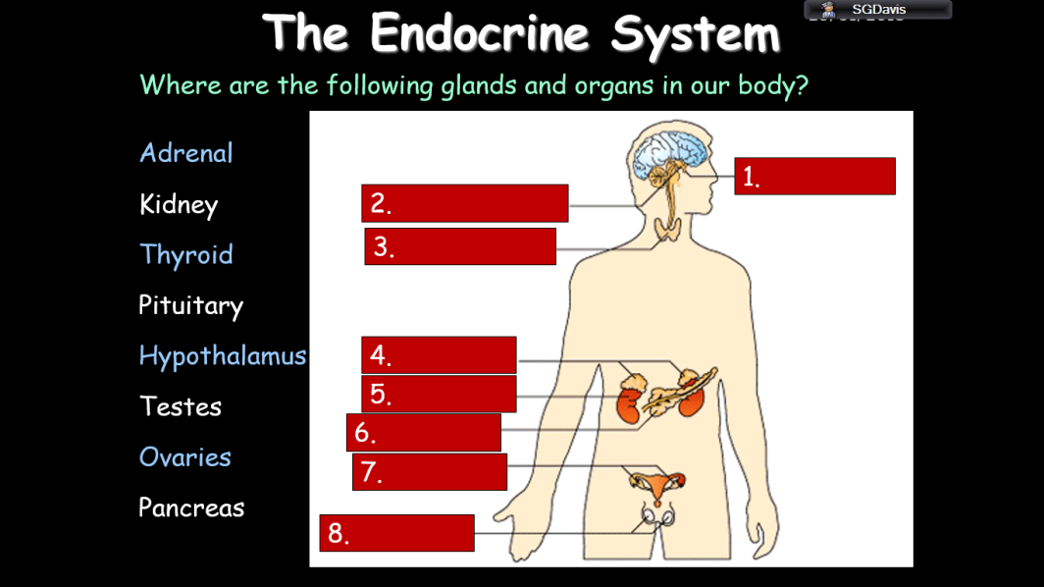 | 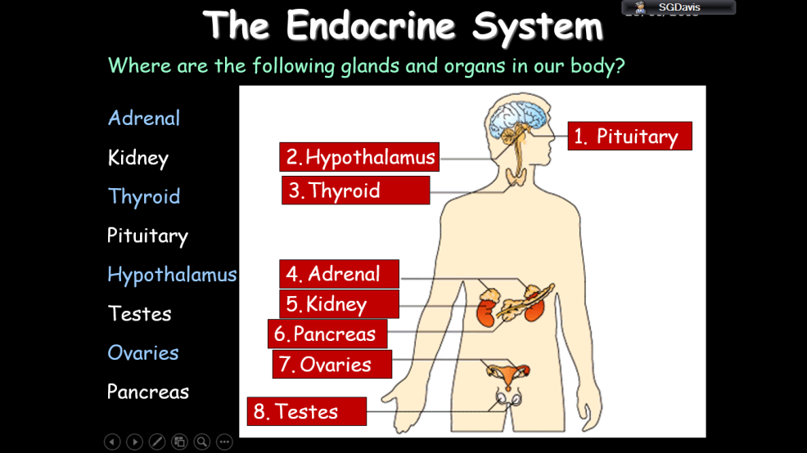
Specification 4.5.3 | Which organ monitors and processes glucose concentration in the blood? | The pancreas
Specification 4.5.3 | What does the pancreas do if the glucose concentration is too high in the blood? | The pancreas produces the hormone insulin that causes glucose to move from the blood into the cells
Specification 4.5.3 | Where does excess glucose get processed? | In liver and muscle cells.
Specification 4.5.3 | How is excess glucose processed? | Excess glucose is converted to glycogen for storage.
Specification 4.5.3 | What is type 1 diabetes? | The pancreas fails to produce sufficient insulin.
Specification 4.5.3 | What are the characteristics of type 1 diabetes? | Uncontrolled high blood glucose levels
Specification 4.5.3 | How is type 1 diabetes treated? | It is normally treated with insulin injections.
Specification 4.5.3 | What is type 2 diabetes? | The body cells no longer respond to insulin produced by the pancreas.
Specification 4.5.3 | How can type 2 diabetes be controlled? | A carbohydrate controlled diet and an exercise regime are common treatments. Obesity is a risk factor for Type 2 diabetes.
Specification 4.5.3 | HIGHER ONLY  How does the body respond if the blood glucose concentrations are too low? | The pancreas produces the hormone glucagon that causes glycogen to be converted into glucose and released into the blood.
Specification 4.5.3 | When you exhale, carbon dioxide gases leaves the lungs. What other substance is released? | Water.
Specification 4.5.3 | What substances are released through sweating? | Water, ions and urea.
Specification 4.5.3 | Where does excess water, ions and urea get removed from the body? | Via the kidneys and in urine.
Specification 4.5.3 | What happens if a cell loses or gain too much water (through osmosis)? | They do not function efficiently.
Specification 4.5.3 | HIGHER ONLY  When proteins are digested which substance in excess need to be safely removed? | Amino acids.
Specification 4.5.3 | Where are excess amino acids treated in the body? | In the liver these amino acids
Specification 4.5.3 | What happens to excess amino acids treated in the liver? | Deaminated to form ammonia.
Specification 4.5.3 | Why is Ammonia immediately converted into urea in the body? | Ammonia is toxic and so it is immediately converted to urea for safe excretion.
Specification 4.5.3 | How do the kidneys work? | The kidneys produce urine by filtration of the blood and selective reabsorption of useful substances such as glucose, some ions and water
Specification 4.5.3 | HIGHER ONLY  Which hormone in the body controls water levels? | ADH (anti diuretic hormone)
Specification 4.5.3 | HIGHER ONLY  Where is ADH released? | ADH is released by the pituitary gland
Specification 4.5.3 | HIGHER ONLY  When is ADH released? | When the blood is too concentrated
Specification 4.5.3 | HIGHER ONLY  What does ADH do? | It causes more water to be reabsorbed back into the blood from the kidney tubules.
Specification 4.5.3 | How might people with kidney failure be treated? | Organ transplant or by using kidney dialysis
Specification 4.5.3 | What happens to a person’s body during puberty? | Reproductive hormones cause secondary sex characteristics to develop
Specification 4.5.3 | What is the name of the female hormone produced in the ovary? | Oestrogen
Specification 4.5.3 | What is ovulation? | At puberty, eggs begin to mature and one is released  approximately every 28 days.
Specification 4.5.3 | What is the name of the male hormone that is produced in the testes? | Testosterone.
Specification 4.5.3 | What are the 4 main hormones used in the menstrual cycle? What do they do? | Several hormones are involved in the menstrual cycle of a woman.  • Follicle stimulating hormone (FSH) causes maturation of an egg in the ovary.  • Luteinising hormone (LH) stimulates the release of the egg.  • Oestrogen and progesterone are involved in maintaining the uterus lining.
Specification 4.5.3 | How can fertilised be controlled? | A variety of hormonal and non-hormonal methods of contraception.
Specification 4.5.3 | How do oral contraceptives work? | Oral contraceptives that contain hormones to inhibit FSH production so that no eggs mature
Specification 4.5.3 | How does injection, implant or skin contraception work? | Slow release progesterone to inhibit the maturation and release of eggs for a number of months or years
Specification 4.5.3 | What is the barrier method of contraception? | Condoms and diaphragms which prevent the sperm reaching an egg
Specification 4.5.3 | How do intrauterine devices work to prevent pregnancy? | Intrauterine devices which prevent the implantation of an embryo or release a hormone
Specification 4.5.3 | What do spermicidal agents do? | Spermicidal agents which kill or disable sperm
Specification 4.5.3 | What method of contraception involves neither hormones, intrauterine devices nor barriers? | Abstaining from intercourse (when an egg may be in the oviduct)
Specification 4.5.3 | What will stop a person being able to conceive? | Surgical methods of male and female sterilisation.
Specification 4.5.3 | HIGHER ONLY  What hormones are given to woman to encourage their fertility? | FSH and LH.
Specification 4.5.3 | HIGHER ONLY  Describe the steps in IVF (4 main stages) | In Vitro Fertilisation (IVF) treatment.  • IVF involves giving a mother FSH and LH to stimulate the maturation of several eggs.  • The eggs are collected from the mother and fertilised by sperm from the father in the laboratory.  • The fertilised eggs develop into embryos.  • At the stage when they are tiny balls of cells, one or two embryos are inserted into the mother’s uterus (womb).
Specification 4.5.3 | HIGHER ONLY  What are the negatives of IVF? | • It is very emotionally and physically stressful  • The success rates are not high  • It can lead to multiple births which are a risk to both the babies and the mother.
Specification 4.5.3 | HIGHER ONLY  Where is adrenaline produced? | Adrenaline is produced by the adrenal glands
Specification 4.5.3 | HIGHER ONLY  When is adrenaline produced? | During fear or stress
Specification 4.5.3 | HIGHER ONLY  How does adrenaline affect the body? | It increases the heart rate and boosts the delivery of oxygen and glucose to the brain and muscles, preparing the body for ‘flight or fight’.
Specification 4.5.3 | Which hormone stimulates the metabolic rates in the body? | Thyroxine from the thyroid gland
Specification 4.5.3 | What does thyroxine do? | It plays an important role in growth and development.
Specification 4.5.3 | What process controls thyroxine levels in the body? | Negative feedback.

B6 Inheritance, variation and evolution (Paper 2) – QUICK QUIZ QUESTIONS
Spec | QUESTION | ANSWER | TICK
4.6.1 | On a cellular level what does sexual reproduction involve? | Sexual reproduction involves the joining (fusion) of male and female sex cells
4.6.1 | What is the name given to the sex cells? | Gametes
4.6.1 | What are the gametes in animals? | Sperm and egg cells
4.6.1 | What are the gametes in plants? | Pollen and egg cells in flowering plants.
4.6.1 | What is sexual reproduction on a genetic level? | A mixing of genetic information which leads to variety in the offspring.
4.6.1 | What is the name of the process in the formation of gametes? | Meiosis.
4.6.1 | What is asexual reproduction? | Involves only one parent and no fusion of gametes
4.6.1 | On a genetic level what does asexual reproduction offer? | There is no mixing of genetic information
4.6.1 | What is the advantage of asexual reproduction? | This leads to genetically identical offspring (clones). Only mitosis is involved.
4.6.1 | Describe the stages when a cell divides to form a gamete | • Copies of the genetic information are made  • The cell divides twice to form four gametes, each with a single set of chromosomes  • All gametes are genetically different from each other.
4.6.1 | How many chromosomes does a gamete have compared with a normal cell? | A gamete has half the number of chromosomes compared with a normal cell.
4.6.1 | How do normal cells end up with a normal number of chromosomes? | Gametes join at fertilisation to restore the normal number of chromosomes.
4.6.1 | What is the name of the process through which normal cells divide? | Mitosis.
4.6.1 | What does mitosis lead to? | The number of cells increases.
4.6.1 | What happens to the cells in an embryo as the cells develop further? | Cells differentiate.
Specification 4.6.1 | What characteristics are controlled by a single gene? | Fur colour in mice and red-green colour blindness in humans.
Specification 4.6.1 | What do alleles do? | Operate at a molecular level to develop characteristics
Specification 4.6.1 | Which type of allele tends to be expressed? | A dominant allele is always expressed, even if only one copy is present.
Specification 4.6.1 | When does a dominant allele tend to NOT be expressed? | When recessive alleles are present. A recessive allele is only expressed if two copies are present (therefore no dominant allele present).
Specification 4.6.1 | What happens if two alleles are present at the same time for a particular trait? | The organism is homozygous for that trait
Specification 4.6.1 | What happens if two different alleles are present for a trait? | The organism is heterozygous for that trait.
Specification 4.6.1 | What causes most characteristics to be different in different organisms? | Most characteristics are a result of multiple genes interacting, rather than a single gene.
Specification 4.6.1 | Name two inherited disorders (inherited through certain alleles) | • Polydactyl (having extra fingers or toes) is caused by a dominant allele.  • Cystic fibrosis (a disorder of cell membranes) is caused by a recessive allele.
Specification 4.6.1 | How many pairs of chromosomes does a normal human cell have? | 23 pairs of chromosomes.
Specification 4.6.1 | How many pairs of chromosomes determine characteristics? | 22 pairs control characteristics
Specification 4.6.1 | How many pairs of chromosomes determine the gender of a human? | 1 pair
Specification 4.6.1 | What are the pairs of chromosomes that make up a male? | In males the chromosomes are different (XY).
Specification 4.6.1 | What are the pairs of chromosomes that make up a female? | In females the sex chromosomes are the same (XX).
Specification 4.6.2 | List 3 things that cause characteristics in individuals to be different | • The genes they have inherited (genetic causes)  • The conditions in which they have developed (environmental causes)  • A combination of genes and the environment.
Specification 4.6.2 | How likely will a mutation lead to a new phenotype? | Very rarely.
Specification 4.6.2 | What will happen if a new phenotype is suited to an environmental change? | It can lead to a relatively rapid change in the species.
Specification 4.6.2 | What is the theory of evolution by natural selection? | All species of living things have evolved from simple life forms that fist developed more than three billion years ago.
Specification 4.6.2 | How is a difference in two species (with a common) ancestor defined? | If two populations of one species become so different in phenotype that they can no longer interbreed to produce fertile offspring they have formed two new species.
Specification 4.6.2 | What is selective breeding? | Selective breeding (artificial selection) is the process by which humans breed plants and animals for particular genetic characteristics.
Specification 4.6.2 | Why do humans carry out selective breeding? | Humans breed plants and animals for particular genetic characteristics.
Specification 4.6.2 | How long have humans selectively bred? | Thousands of years since they first bred food crops from wild plants and domesticated animals.
Specification 4.6.2 | How does selective breeding work? | Selective breeding involves choosing parents with the desired characteristic from a mixed population. They are bred together. From the offspring those with the desired characteristic are bred together. This continues over many generations until all the offspring show the desired characteristic.
Specification 4.6.2 | What sort of characteristics do humans look for when selective breeding? | • Disease resistance in food crops.  • Animals which produce more meat or milk.  • Domestic dogs with a gentle nature.  • Large or unusual flowers.
Specification 4.6.2 | What is inbreeding? | Some breeds are particularly prone to disease or inherited defects.
Specification 4.6.2 | Why might humans genetically engineer plants? | To be resistant to diseases or to produce bigger better fruits.
Specification 4.6.2 | Why have bacterial cells been genetically engineered? | To produce useful substances such as human insulin to treat diabetes
Specification 4.6.2 | How does genetic engineering work? | Genes from the chromosomes of humans and other organisms can be ‘cut out’ and transferred to cells of other organisms.
Specification 4.6.2 | What is the name given to crops that have been genetically modified? | Genetically modified (GM) crops.
Specification 4.6.2 | What are the characteristics of genetically modified crops? | They are resistant to insect attack or to herbicides. They also show an increase yield.
Specification 4.6.2 | What are the concerns about GM crops? | The effect on populations of wild flowers and insects.
Specification 4.6.2 | People sometimes claim they feel the effects of GM. Has this been explored scientifically? | There has been no full investigation.
Specification 4.6.2 | What is modern medicine exploring with regards to genetic modification? | To overcome some inherited disorders.
Specification 4.6.2 | Higher only  Explain the stages in genetic engineering | (HT only) In genetic engineering:  •Enzymes are used to isolate the required gene; this gene is inserted into a vector, usually a bacterial plasmid or a virus  •The vector is used to insert the gene into the required cells  •Genes are transferred to the cells of animals, plants or microorganisms at an early stage in their development so that they  develop with desired characteristics.
Specification 4.6.4 | What is a fossil? | Fossils are the ‘remains’ of organisms from millions of years ago, which are found in rocks.
Specification 4.6.4 | What are the 3 main ways fossils form? | • From parts of organisms that have not decayed because one or more of the conditions needed for decay are absent  • when parts of the organism are replaced by minerals as they decay  • As preserved traces of organisms, such as footprints, burrows and rootlet traces.
Specification 4.6.4 | Why have many traces of early life forms not survived? | Many early forms of life were soft-bodied, which means that they have left few traces behind.
Specification 4.6.4 | What has happened to the traces of early life that have survived? | What traces there were have been mainly destroyed by geological activity. This is why scientists cannot be certain about how life began on Earth.
Specification 4.6.4 | What can we learn from fossils? | We can learn from fossils how much or how little different organisms have changed as life developed on Earth.
Specification 4.6.4 | What is extinction? | Extinctions occur when there are no remaining individuals of a species still alive.
Specification 4.6.4 | Why can bacteria evolve quickly? | They reproduce at a fast rate.
Specification 4.6.4 | Why are bacterial pathogens becoming resistant to antibiotics? | Mutations of bacterial pathogens produce new strains. Some strains might be resistant to antibiotics, and so are not killed.
Specification 4.6.4 | How does surviving bacteria create even more antibiotic resistant strains? | They survive and reproduce, so the population of the resistant strain rises.
Specification 4.6.4 | Why does a resistant bacterium spread so quickly? | People are not immune to it and there is no effective treatment.
Specification 4.6.4 | Name a bacterium resistant to all antibiotics. | MRSA
Specification 4.6.4 | Name 3 ways we can reduce the rate of development of antibiotic resistant strains. | • Doctors should not prescribe antibiotics inappropriately, such as treating non-serious or viral infections  • Patients should complete their course of antibiotics so all bacteria are killed and none survive to mutate and form resistant strains  • The agricultural use of antibiotics should be restricted.
Specification 4.6.4 | Why can’t recreate new antibiotics fast enough to cope with resistant strains? | The development of new antibiotics is costly and slow. It is unlikely to keep up with the emergence of new resistant strains.
Specification 4.6.4 | How did Carl Linnaeus first classify all living things? | Traditionally living things have been classified into groups depending on their structure and characteristics.
Specification 4.6.4 | What are the classifications Linnaeus used for all living things? | Kingdom, phylum, class, order, family, genus and species.
Specification 4.6.4 | How are organisms named? | Organisms are named by the binomial system of genus and species.
Specification 4.6.4 | Why were more classifications added more recently? | As evidence of internal structures became more developed due to improvements in microscopes, and the understanding of biochemical processes progressed, new models of classification were proposed.
Specification 4.6.4 | Due to new types of chemical analysis, Carl Woese introduced a new classification system. What is the name of this system? | ‘The three domain system’.
Specification 4.6.4 | How are living things divided in the three domain system? | • Achaea (primitive bacteria usually living in extreme environments)  • Bacteria (true bacteria)  • Eukaryota (which includes protists, fungi, plants and animals).
Specification 4.6.4 | What are evolutionary trees? | A method used by scientists to show how they believe organisms are related.
Specification 4.6.4 | Where does the data come from when writing an evolutionary tree? | They use current classification data for  living organisms and fossil data for extinct organisms.

B7 Ecology (Paper 2) – QUICK QUIZ QUESTIONS
Spec | QUESTION | ANSWER | TICK
Specification 4.7.1 | What is an ecosystem? | The interaction of a community of living organisms (biotic) with the non-living (abiotic) parts of their environment.
Specification 4.7.1 | What do organisms need to survive and reproduce? | Organisms require a supply of materials from their surroundings and from the other living organisms there.
Specification 4.7.1 | What do plants in a community or habitat often compete for? | Light, space, water and mineral ions from the soil.
Specification 4.7.1 | What do animals in a community compete for? | Animals often compete with each other for food, mates and territory.
Specification 4.7.1 | Within a community, what does each species depend on others for? | Food, shelter, pollination, seed dispersal etc
Specification 4.7.1 | What happens if one species is removed from a community? | If one species is removed it can affect the whole community.
Specification 4.7.1 | What is the name given to the relationship between different species in a community or habitat? | Interdependence
Specification 4.7.1 | What makes a community stable? | All the species and environmental factors are in balance so that population sizes remain fairly constant.
Specification 4.7.1 | What abiotic factors affect a community? | • Light intensity  • Temperature  • Moisture levels  • Soil pH and mineral content  • Wind intensity and direction  • Carbon dioxide levels for plants  • Oxygen levels for aquatic animals.
Specification 4.7.1 | What biotic factors affect a community? | • Availability of food  • New predators arriving  • New pathogens  • One species outcompeting another so the numbers are no longer sufficient to breed.
Specification 4.7.1 | What do organisms have that enable them to survive in their habitat? | Adaptations.
Specification 4.7.1 | What form may adaptation take? | Structural, behavioural or functional.
Specification 4.7.1 | What is the name given to organisms that live in extreme environments (high temperature, pressure or salt concentrations) | Extremophiles
Specification 4.7.1 | Give an example of an extremophile | Bacteria living in deep sea vents.
Specification 4.7.2 | How are feeding relationships represented? | Food chains
Specification 4.7.2 | What do all food chains begin with? | A Producer
Specification 4.7.2 | What organisms are usually producers? | Green plants or alga
Specification 4.7.2 | Name some methods ecologists use to measure the environment | Transects and quadrats  Pooters  Habitat sensors  Cameras/recording equipment
Specification 4.7.2 | Who in the food chain consumes producers? | Primary consumers.
Specification 4.7.2 | Who in the food chain consumes primary consumers? | Secondary consumers.
Specification 4.7.2 | What are the names given to consumers that eat other animals? | Predators
Specification 4.7.2 | What are the names given to animals eaten by consumers? | Prey
Specification 4.7.2 | In a stable community how do the number of predators and prey vary? | They rise and fall in cycles.
Specification 4.7.2 | What happens to materials in the living world once an organism dies? | All materials in the living world are recycled to provide the building blocks for future organisms
Specification 4.7.2 | What does the carbon cycle do? | Returns carbon from organisms to the atmosphere as carbon dioxide to be used by plants in photosynthesis.
Specification 4.7.2 | How does the water cycle help organisms? | The water cycle provides fresh water for plants and animals on land before draining into the seas.
Specification 4.7.2 | What are the names of the two processes by which water is collected and distributed in the water cycle? | Evaporated and precipitation.
Specification 4.7.3 | What is biodiversity? | The variety of all the different species of organisms on earth, or within an ecosystem
Specification 4.7.3 | What does great biodiversity ensure? | The stability of ecosystems by reducing the dependence of one species on another for food, shelter and the maintenance of the physical environment.
Specification 4.7.3 | What impact does a good level of biodiversity have on humans? | The future of the human species on Earth.
Specification 4.7.3 | Why are more resources (and waste) being used and created at the moment? | Rapid growth in the human population and an increase in the standard of living.
Specification 4.7.3 | Why will pollution continue to increase? | Waste and chemical materials need to be properly handled and they are currently not.
Specification 4.7.3 | Where can pollution occur? | • In water, from sewage, fertiliser or toxic chemicals  • In air, from smoke and acidic gases  • On land, from landfill and from toxic chemicals.
Specification 4.7.3 | What does pollution do to biodiversity? | Pollution kills plants and animals which can reduce biodiversity.
Specification 4.7.3 | How do humans reduce the amount of land available to plants and animals? | By building, quarrying, farming and dumping waste.
Specification 4.7.3 | What will the destruction of peat bogs and other compost areas lead to? | Reduces the area of this habitat and thus the  variety of different plant, animal and microorganism species that live there (biodiversity).
Specification 4.7.3 | What does the decay or burning of peat lead to for our environment? | The decay or burning of the peat releases carbon dioxide into the atmosphere
Specification 4.7.3 | What are the purposes of large scale deforestation? | • provide land for cattle and rice fields  • grow crops for biofuels
Specification 4.7.3 | What does increased levels of carbon dioxide and methane lead to in the atmosphere? | ‘Global warming’.
Specification 4.7.3 | What programmes are in place to protect our ecosystems? | • Breeding programmes for endangered species  • Protection and regeneration of rare habitats  • Reintroduction of field margins and hedgerows in agricultural areas where farmers grow only one type of crop  • Reduction of deforestation and carbon dioxide emissions by some  governments  • Recycling resources rather than dumping waste in landfill.

