JOG Science Faculty Revision Support

Chemistry PAPER 1 Quick Quiz Sheets

CONTENT
- (C1) Atomic structure and the periodic table

- (C2) Bonding, structure, and the properties of matter

- (C3) Quantitative chemistry

- (C4) Chemical changes

- (C5) Energy changes
Parents and guardians frequently inquire about how they can support their children in preparing for their science exams. Quick quiz sheets offer an opportunity for parental involvement in the revision journey. These sheets contain crucial information essential for success in the GCSE science exams, allowing families to memorise important facts together. Additionally, personalised learning checklists are provided for each module, enabling students to track their progress effectively.

C1 Atomic structure and the periodic table (PAPER 1) – QUICK QUIZ QUESTIONS
Spec | QUESTION | ANSWER | TICK
Specification 4.1.1 | What are all substances made from? | Atoms
Specification 4.1.1 | How are chemicals represented in chemistry? | Chemical symbol
Specification 4.1.1 | How many elements are there? Where would a chemist look these up? | There are about 100 different elements Elements are shown in the periodic table
Specification 4.1.1 | What are compounds? | Compounds are formed from elements by chemical reactions
Specification 4.1.1 | How would you know if a chemical reaction has happened? | The formation of one or more new substances, and often involve a detectable energy change
Specification 4.1.1 | How might you separate a compound into a separate element? | Separated into elements by chemical reactions
Specification 4.1.1 | How do chemists represent chemical reactions? | Word equations or equations using symbols and formulae
Specification 4.1.1 | What is a mixture? | Two or more elements or compounds not chemically combined together
Specification 4.1.1 | What can be said about the properties of chemicals in mixtures? | The properties of each substance in the mixture are unchanged
Specification 4.1.1 | List 5 ways that mixtures might be separated | - Filtration  - Crystallisation  - Simple distillation  - Fractional distillation  - Chromatography
Specification 4.1.1 | What might happen to a scientific model if new evidence is discovered? | A scientific model being changed or replaced
Specification 4.1.1 | Before the electron was discovered, what did people think atoms were? | Tiny spheres that could not be divided
Specification 4.1.1 | What was the name of the atomic model that the electron led to? | The plum pudding model
Specification 4.1.1 | What was the plum pudding model of the atom? | The atom is a ball of positive charge with negative electrons embedded in it
Specification 4.1.1 | What did scientists learn about the atom from the alpha particle scattering experiment? | - The mass of an atom was concentrated at the centre (nucleus)  - The nucleus was positively charged  - Electrons were in orbit
Specification 4.1.1 | What model replaced the plum pudding model of the atom? | The nuclear model
Specification 4.1.1 | How did Niels Bohr adapt the nuclear model of the atom? | He suggested electrons orbit the nucleus at specific distances
Specification 4.1.1 | What happened next as the atomic model slowly improved? | Later experiments led to the idea that the positive charge of any nucleus could be subdivided into smaller parts
Specification 4.1.1 | What is the name given to positive particles in the atom? | Proton
Specification 4.1.1 | What particle did James Chadwick discover that helped support the new atomic model of atoms? | Neutron
Specification 4.1.1 | What is the relative charge on a proton? | Positive
Specification 4.1.1 | What is the relative charge on a neutron? | Neutral
Specification 4.1.1 | What is the relative charge on an electron? | Negative
Specification 4.1.1 | How do the number of electrons and number of protons compare in a normal atom? | The number of electrons is equal to the number of protons
Specification 4.1.1 | What is the atomic number of an atom? | The number of protons in an atom
Specification 4.1.1 | What is similar about all atoms of a particular element? | Same number of protons
Specification 4.1.1 | If the numbers of protons change in an element, i.e. what happens to the element? | You have a different element
Specification 4.1.1 | How large are atoms? | Atoms are very small, having a radius of about 01 nm (1 x 10⁻¹⁰ m)
Specification 4.1.1 | What is the radius of an atom? | The radius of a nucleus is less than 1/10 000 of that of the atom (about 1 x 10⁻¹⁴ m)
Specification 4.1.1 | Where is most of the mass of the atom? | Almost all of the mass of an atom is in the nucleus
Specification 4.1.1 | What is the relative mass of a proton? | 1
Specification 4.1.1 | What is the relative mass of a neutron? | 1
Specification 4.1.1 | What is the relative mass of an electron? | Almost nothing (1/2000th of the proton)
Specification 4.1.1 | What is the mass number of an atom? | The sum of the protons and neutrons
Specification 4.1.1 | What is an isotope? | Atoms of the same element can have different numbers of neutrons
Specification 4.1.1 | What is the relative atomic mass? | Average number of protons and neutrons in the nucleus
Specification 4.1.1 | What energy levels do electrons choose to occupy when no other electrons are around? | The lowest available energy levels
Specification 4.1.1 | How is the electron structure of an atom represented? | Numbers or by a diagram
Specification 4.1.1 | Represent the structure of sodium with numbers and a diagram The atomic number for sodium is 11 | The electronic structure of sodium is 2,8,1 or  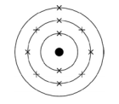
Specification 4.1.2 | How are elements in the periodic table arranged? | Arranged in order of atomic (proton) number
Specification 4.1.2 | How are elements with similar properties arranged? | Elements with similar properties are in columns, known as groups
Specification 4.1.2 | What can be said about the electrons in the outer shells of elements in the same groups? | The same number of electrons
Specification 4.1.2 | Before electrons, protons and neutrons were discovered, how did scientists classify elements? | By arranging them in order of their atomic weights
Specification 4.1.2 | What happened in the early tables of elements when classified by weight? | They were incomplete and some elements were placed in inappropriate groups
Specification 4.1.2 | How did Mendeleev overcome the problems in his periodic table when arranging elements by protons, neutrons and electrons? | Leaving gaps for elements
Specification 4.1.2 | What happened to the elements discovered later by scientists? | Filled the gaps left my Mendeleev
Specification 4.1.2 | What did the discovery of isotopes help explain? | The order of elements based on atomic weights was not always correct
Specification 4.1.2 | What types of elements react to form positive ions? | Metals
Specification 4.1.2 | What type of elements react to form negative ions | Non-metals
Specification 4.1.2 | What type of element is most common on the periodic table? | The majority of elements are metals
Specification 4.1.2 | Where are nonmetals found on the periodic table? | Non-metals are found towards the right and top of the periodic table
Specification 4.1.2 | What are the elements in group 0 called on the periodic table? | The noble gases
Specification 4.1.2 | What are the properties of group 0 elements? | They are unreactive
Specification 4.1.2 | How many electrons do the noble gases have in their outer shell? | The noble gases have eight electrons in their outer shell
Specification 4.1.2 | What happens to the boiling points of the noble gases going down the group? | The boiling points of the noble gases increase going down the group
Specification 4.1.2 | What are the names of the elements in group 1 of the periodic table called? | Alkali metals
Specification 4.1.2 | Why do the alkali metals all have similar properties? | Single electron in their outer shell
Specification 4.1.2 | What happens to the reactivity of the alkali metals going down the group? | In Group 1, the reactivity of the elements increases going down the group
Specification 4.1.2 | What is the name given to group 7 elements? | The halogens
Specification 4.1.2 | Why do the halogens have similar properties? | Seven electrons in their outer shell
Specification 4.1.2 | Are the halogen (group 7) metals or non-metals? How are they normally found? | Non-metals and consist of molecules made of pairs of atoms
Specification 4.1.2 | What happens to the melting and boiling points of the halogens down the group? | Increase down the group
Specification 4.1.2 | What happens to the reactivity of the halogens down the group? | Decreases down the group
Specification 4.1.2 | What is a more reactive halogen able to do to a less reactivity halogen? | Displace a less reactive halogen (swap with it)
C2 Bonding, structure and properties of matter (PAPER 1) – QUICK QUIZ QUESTIONS
Spec | QUESTION | ANSWER | TICK
Specification 4.2.1 | Name the three types of chemical bond | Ionic, covalent and metallic
Specification 4.2.1 | Describe ionic bonding | Particles are oppositely charged ions that attract
Specification 4.2.1 | Describe covalent bonding | Particles are atoms which share pairs of electrons
Specification 4.2.1 | Describe metallic bonding | Metal atoms share delocalised electrons
Specification 4.2.1 | Where does covalent bonding normally happen? | Non-metallic elements and compounds
Specification 4.2.1 | Where does metallic bonding normally happen? | Metallic elements and alloys
Specification 4.2.1 | When a metal reacts with a non-metal during ionic bonding, what happens to the electron on the outer shell of the metal? | The electrons are transferred
Specification 4.2.1 | When metal atoms lose electrons, what charge does the ion become (positive or negative)? | Metal atoms lose electrons to become positively charged ions
Specification 4.2.1 | When a nonmetal atom gains an electron, what charge does the ion become (positive or negative)? | Non-metal atoms gain electrons to become negatively charged ions
Specification 4.2.1 | Draw a dot cross diagram for sodium reacting with chlorine Ignore drawing the nucleus of the atom | 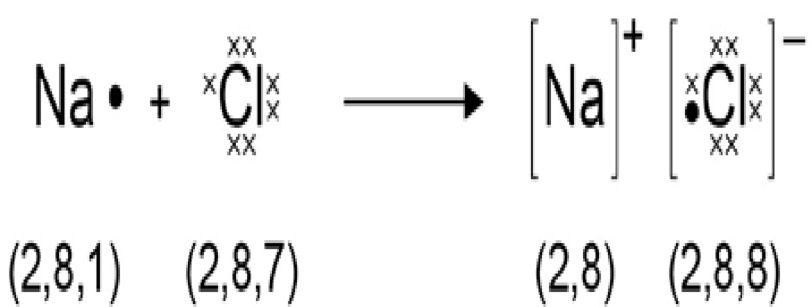
Specification 4.2.1 | How could you describe an ionic compound? | A giant structure of ions
Specification 4.2.1 | Describe how ionic compounds are held together | Strong electrostatic forces of attraction between oppositely charged ions
Specification 4.2.1 | What directions do the forces act in during ionic bonding? | All directions in the lattice
Specification 4.2.1 | Sketch how ionic bonding might be represented in the exam | 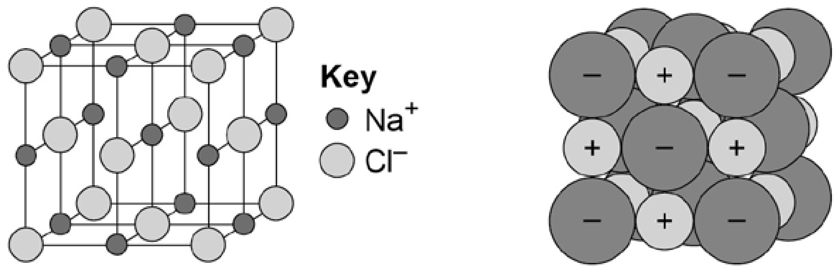
Specification 4.2.1 | When atoms share electrons, what type of bonding is this? | Covalent bonds
Specification 4.2.1 | Is covalent bonding strong or weak? | Strong
Specification 4.2.1 | What type of bonding do small molecules typically have? | Covalently bonded
Specification 4.2.1 | What is the name of very long covalently bonded compounds? | Polymers
Specification 4.2.1 | What materials are giant covalent structures? | Diamond and silicon dioxide
Specification 4.2.1 | Sketch a dot cross diagram for a covalently bonded compound | 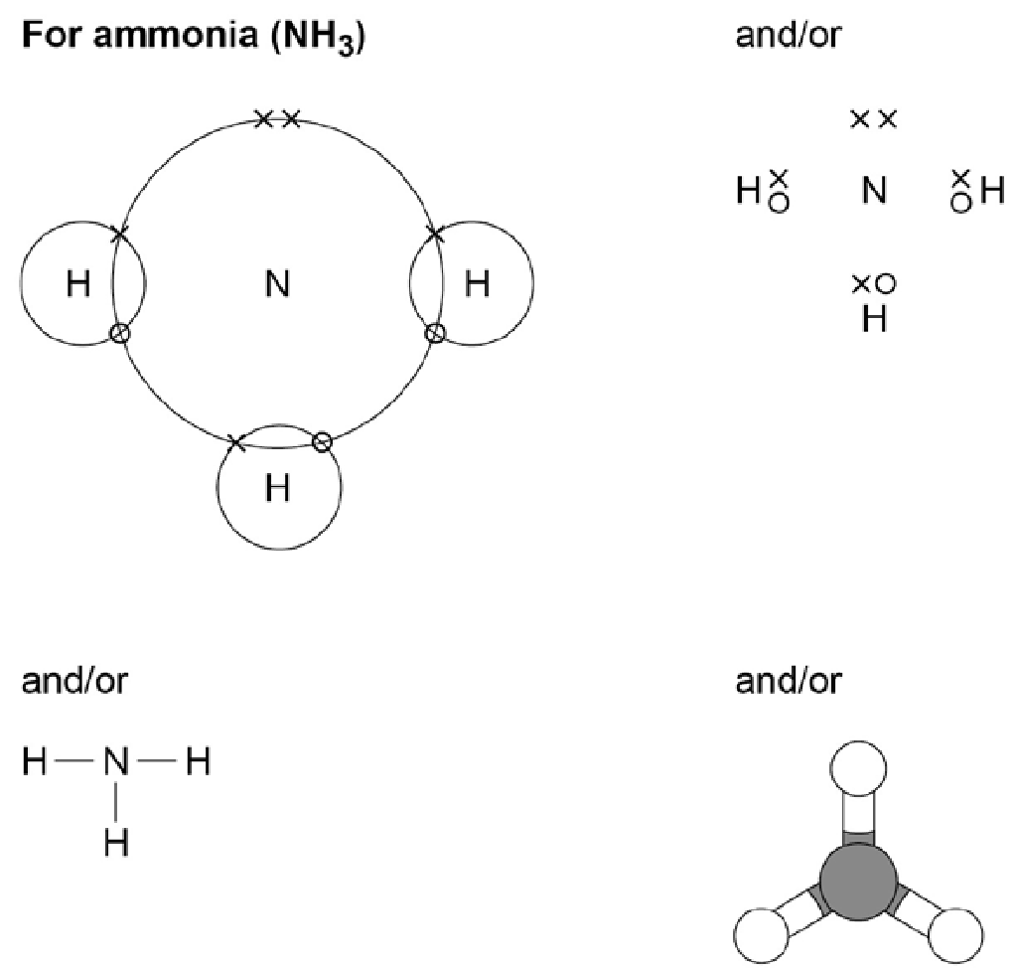
Specification 4.2.1 | Sketch how a polymer might be represented in the examination | 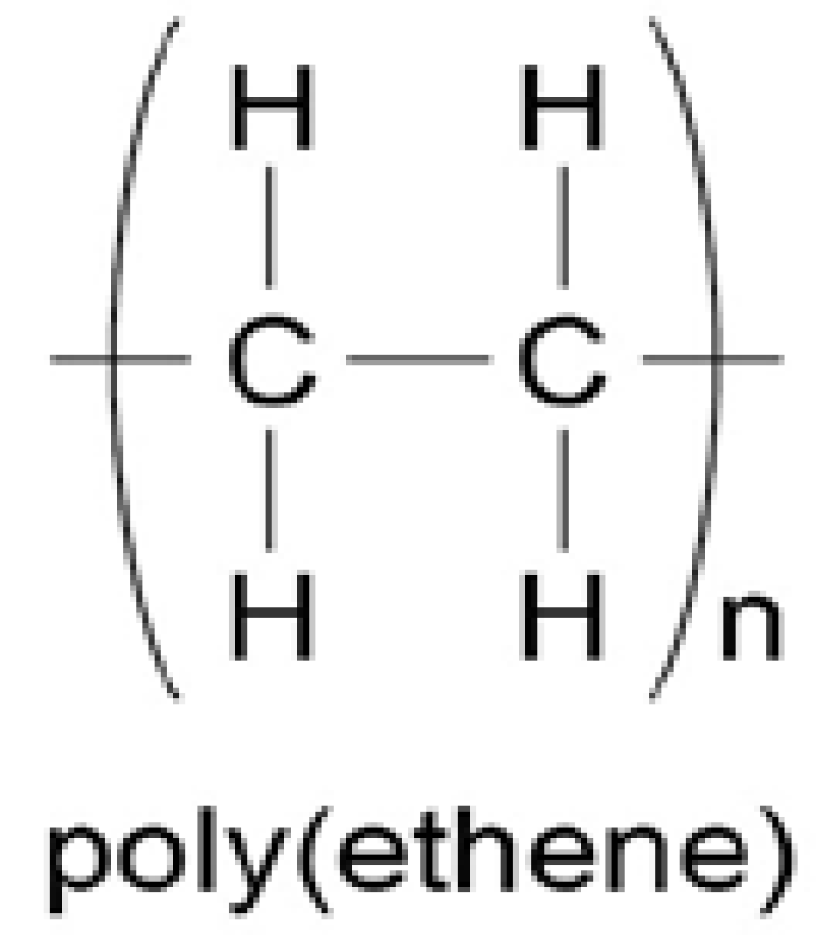
Specification 4.2.1 | How could you describe a metal structure? | Giant structures of atoms arranged in a regular pattern
Specification 4.2.1 | How do electrons behave in metallic bonding? | The electrons in the outer shell of metal atoms are delocalised and so are free to move through the whole structure
Specification 4.2.1 | Is metallic bonding strong or weak? | Strong
Specification 4.2.1 | Sketch how you might find metallic bonding represented in the examination | 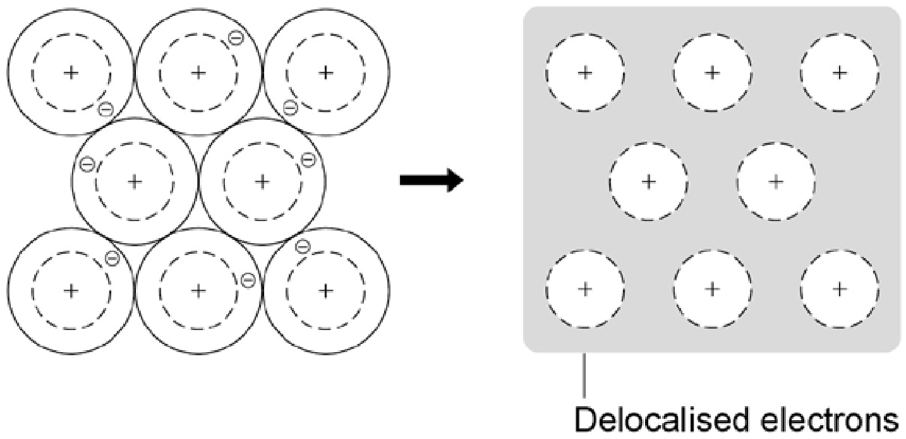
Specification 4.2.2 | What are the three states of matter? | The three states of matter are solid, liquid and gas
Specification 4.2.2 | What two state changes happen at the melting point? | Melting and freezing take place at the melting point
Specification 4.2.2 | What two state changes happen at the boiling point? | Boiling and condensing take place at the boiling point
Specification 4.2.2 | Sketch a solid, liquid and a gas | 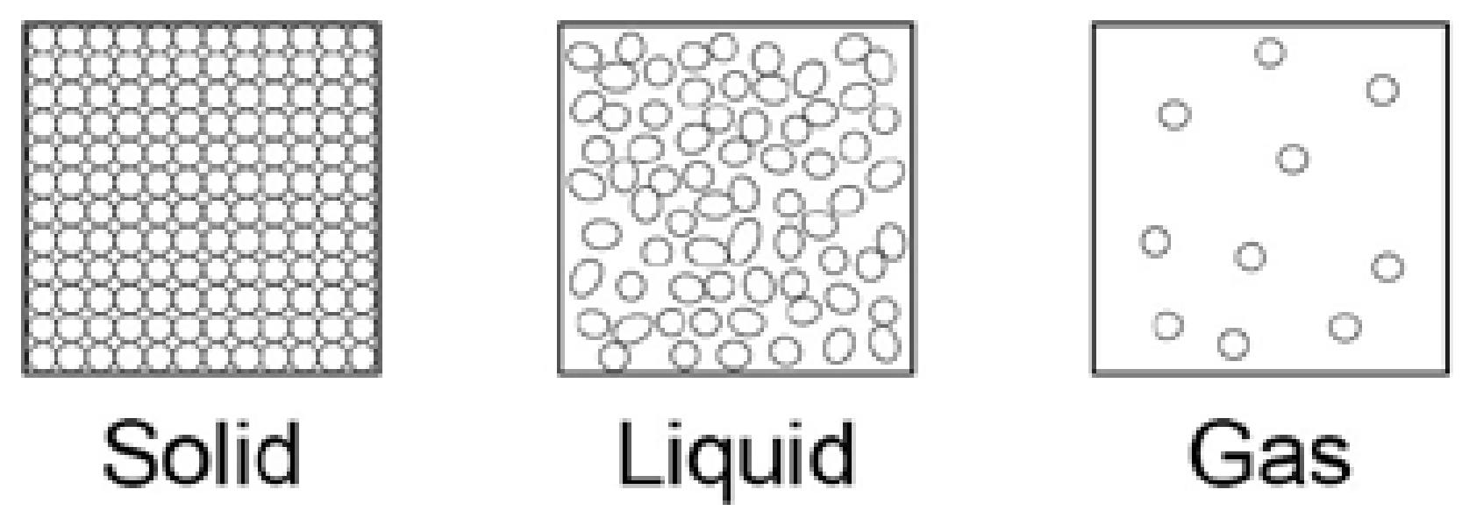
Specification 4.2.2 | How is the energy needed to break bonds and forces between particles related? | The amount of energy needed to break bonds depend on the strength of the forces between the particles
Specification 4.2.2 | If the forces are stronger between particles, how might the boiling point and melting point be affected? | Higher the melting point and boiling point
Specification 4.2.2 | Higher tier only  Name a limitation for the model of solids, liquids and gases | - There are no forces,  - That all particles are represented as spheres  - The spheres are solid
Specification 4.2.2 | How are solids, liquids, gases and aqueous solutions represented in chemical equations? | (s), (l) and (g), with (aq) for aqueous solutions
Specification 4.2.2 | How might you describe ionic bonding in compounds? | Regular structures (giant ionic lattices)
Specification 4.2.2 | What can be said about the melting points and boiling points of ionic compounds? | High melting points and high boiling points
Specification 4.2.2 | When melted or dissolved, what are ionic compounds able to do? | Conduct electricity
Specification 4.2.2 | How would you describe the melting and boiling points in small molecules? | Low melting points and boiling points
Specification 4.2.2 | Why do small molecules have only small melting and boiling points? | Weak forces between the molecules (intermolecular forces)
Specification 4.2.2 | How can small covalent molecules melt and boil or easily when covalent bonding is strong? | It is these intermolecular forces that are overcome, not the covalent bonds, when the substance melts or boils
Specification 4.2.2 | How is the melting point and boiling point of molecules affected with a change in intermolecular force? | Larger molecules have higher melting and boiling points
Specification 4.2.2 | Why don’t covalent substances conduct electricity? | No overall electric charge
Specification 4.2.2 | Do polymers have large or small molecules? | Polymers have very large molecules
Specification 4.2.2 | How are atoms linked together in polymers? | Strong covalent bonds
Specification 4.2.2 | Are polymers solids, liquids or gases at room temperature? Why is this? | Strong bonding so these substances are solids at room temperature
Specification 4.2.2 | Do giant covalent structures have high or low melting points? | Very high melting points
Specification 4.2.2 | How are the atoms linked together in giant covalent molecules? | Strong covalent bonds
Specification 4.2.2 | What must happen to these bonds for the substance to melt or boil? | These bonds must be overcome
Specification 4.2.2 | Give some examples of giant covalent structures | Diamond and graphite (forms of carbon) and silicon dioxide (silica)
Specification 4.2.2 | How do pure metals bend? | In pure metals, atoms are arranged in layers which slide over each other (to cause bending)
Specification 4.2.2 | Why are pure metals made into alloys? | Pure metals are too soft for many uses and so are mixed with other metals to make alloys which are harder
Specification 4.2.2 | Why are metals good conductors of electricity? | Electrons in the metal carry electrical charge through the metal
Specification 4.2.2 | Why are metals good conductors of heat? | Energy is transferred by the delocalised electrons
4.2.3 | How would you describe the bonding between each carbon atom in diamond? | Each carbon atom forms four covalent bonds with other carbon atoms in a giant covalent structure
4.2.3 | Describe the properties of diamond | - very hard  - has a very high melting point  - does not conduct electricity
4.2.3 | How would you describe the bonding between each carbon atom in graphite? | Each carbon atom forms three covalent bonds with three other carbon atoms, forming layers of hexagonal rings
4.2.3 | How many electrons are free for each carbon atom in graphite? | One electron from each carbon atom is delocalised
4.2.3 | What is graphene? | Graphene is a single layer of graphite
4.2.3 | What are fullerenes? | Fullerenes are molecules of carbon atoms with hollow shapes
4.2.3 | How would you describe the structure of a fullerene? | Based on hexagonal rings of carbon atoms but they may also contain rings with five or seven carbon atoms
4.2.3 | What was the first fullerene discovered? | The first fullerene to be discovered was Buckminsterfullerene (C60) which has a spherical shape
4.2.3 | What are carbon nanotubes? | Carbon nanotubes are cylindrical fullerenes with very high length to diameter ratios

C3 Quantitative chemistry (PAPER 1) - Drip questions
Spec | QUESTION | ANSWER | TICK
4.3.1 | What is the law of conservation of mass? | No atoms are lost or made during a chemical reaction so the mass of the products equals the mass of the reactants
4.3.1 | What is the relative formula mass of a compound? | The relative formula mass (Mr) of a compound is the sum of the relative atomic masses of the atoms in the numbers shown in the formula
4.3.1 | In a balanced chemical equation, what can be said about the sum of the relative formula masses from the reactants compared with the products? | They are the same, balanced
4.3.1 | Why might a chemical reaction appear not balanced? | A reactant or product is a gas and its mass has not been taken into account
4.3.1 | What happens to the mass of a metal when it reacts with oxygen? | When a metal reacts with oxygen the mass of the oxide produced is greater than the mass of the metal
4.3.1 | What happens to the mass of a metal carbonate when it undergoes thermal decomposition? | Carbon dioxide is produced and escapes into the atmosphere leaving the metal oxide as the only solid product The overall mass goes down
Specification 4.3.2 | Higher only  What are the units of chemical amounts? | Chemical amounts are measured in moles The symbol for the unit mole is mol
Specification 4.3.2 | Higher only  How much is the mass of 1 mole? | The mass of one mole of a substance in grams is numerically equal to its relative formula mass
Specification 4.3.2 | Higher only  What does a mole mean? | One mole of a substance contains the same number of the stated particles, atoms, molecules or ions as one mole of any other substance
Specification 4.3.2 | Higher only  How many particles, atoms, ions or molecules represent 1 mole? | 6.02 x 10²³ particles per mole
Specification 4.3.2 | Higher only  How do we balance reactants and products in a reaction? | The masses of reactants and products can be calculated from balanced symbol equations
Specification 4.3.2 | Higher only  What does this chemical equation tell us is happening in this reaction?  Mg + 2HCI MgCI₂ + H₂ | Shows that one mole of magnesium reacts with two moles of hydrochloric acid to produce one mole of magnesium chloride and one mole of hydrogen gas
Specification 4.3.2 | Higher only  Why is it common to use excess of a reactant in a chemical reaction? | Ensure that all of the other reactant is used
Specification 4.3.2 | Higher only  What is the name of the reactant that gets completely used up in reaction? | Limiting reactant because it limits the amount of products
Specification 4.3.2 | Higher only  What are the units of concentration in a solution? | Grams per dm3 (g/dm3)
C4 Chemical changes (paper 1)
Spec | QUESTION | ANSWER | TICK
Specification 4.4.1 | What is produced when a metal reacts with oxygen? | Metals react with oxygen to produce metal oxides
Specification 4.4.1 | Why are reactions called oxidation reactions? | Metals gain oxygen
Specification 4.4.1 | What type of ions form when metals react with other substances? | Positive ions
Specification 4.4.1 | What is the reactivity of a metal based on? | Its tendency to form positive ions
Specification 4.4.1 | How can we order metals? | In order of their reactivity (in a reactivity series)
Specification 4.4.1 | What non-metal is found on the reactivity series of metals? | Carbon
Specification 4.4.1 | What is the major rule of the reactivity series? | A more reactive metal can displace a less reactive metal from a compound
Specification 4.4.1 | Where do you find unreactive metals? | Un-reactive metals such as gold are found in the Earth as the metal itself
Specification 4.4.1 | How do we find most metals? | Most metals are found as compounds that require chemical reactions to extract the metal
Specification 4.4.1 | How do we extract metals less reactive than carbon? | Metals less reactive than carbon can be extracted from their oxides by reduction with carbon
Specification 4.4.1 | What is reduction? | Reduction involves the loss of oxygen
Specification 4.4.1 | What is oxidation and reduction in terms of electron movement? | Oxidation is the loss of electrons and reduction is the gain of electrons
Specification 4.4.2 | What is produced when a metal reacts with an acid? | Salts and hydrogen
Specification 4.4.2 | How do you neutralise an acid? | Acids are neutralised by alkalis and bases
Specification 4.4.2 | What are alkalis? | Soluble metal hydroxides (they dissolve)
Specification 4.4.2 | What are bases? | Insoluble metal hydroxides and metal oxides) (they don’t dissolve)
Specification 4.4.2 | What is produced when acids and alkalis (or bases) react? | Salts and water
Specification 4.4.2 | What is produced when an acid reacts with a metal carbonate? | Salts, water and carbon dioxide
Specification 4.4.2 | What does the salt produced depend upon? | • the acid used (hydrochloric acid produces chlorides, nitric acid produces nitrates, sulfuric acid produces sulfates)  • the positive ions in the base, alkali or carbonate i.e. sodium, potassium
Specification 4.4.2 | How can you make a soluble salt? | Soluble salts can be made from acids by reacting them with solid insoluble substances, such as metals, metal oxides, hydroxides or carbonates
Specification 4.4.2 | In brief, explain the scientific process of making a salt | The solid is added to the acid until no more reacts and the excess solid is filtered off to produce a solution of the salt
Specification 4.4.2 | How do you produce solid salts once filtered as a solution? | Salt solutions can be crystallised to produce solid salts
Specification 4.4.2 | What ions do acids produce? | Acids produce hydrogen ions (H+) in aqueous solutions
Specification 4.4.2 | What ions do alkalis produce? | Aqueous solutions of alkalis contain hydroxide ions (OH–)
Specification 4.4.2 | What is the pH scale? | The pH scale, from 0 to 14, is a measure of the acidity or alkalinity of a solution,
Specification 4.4.2 | How can you measure the pH of an acid or alkalis? | Can be measured using universal indicator or a pH  probe
Specification 4.4.2 | If a solution has a pH 7, what is it? | A solution with pH 7 is neutral
Specification 4.4.2 | What pHs do acids have? | 6 or less (7 is neutral)
Specification 4.4.2 | What pHs do alkalis solutions have? | 8 or greater (7 is neutral)
Specification 4.4.2 | What happens during neutralisation? | An acid and an alkali, hydrogen ions react with hydroxide ions to produce water
Specification 4.4.2 | Write the equation down that represents the reaction between acid and alkalis ions | 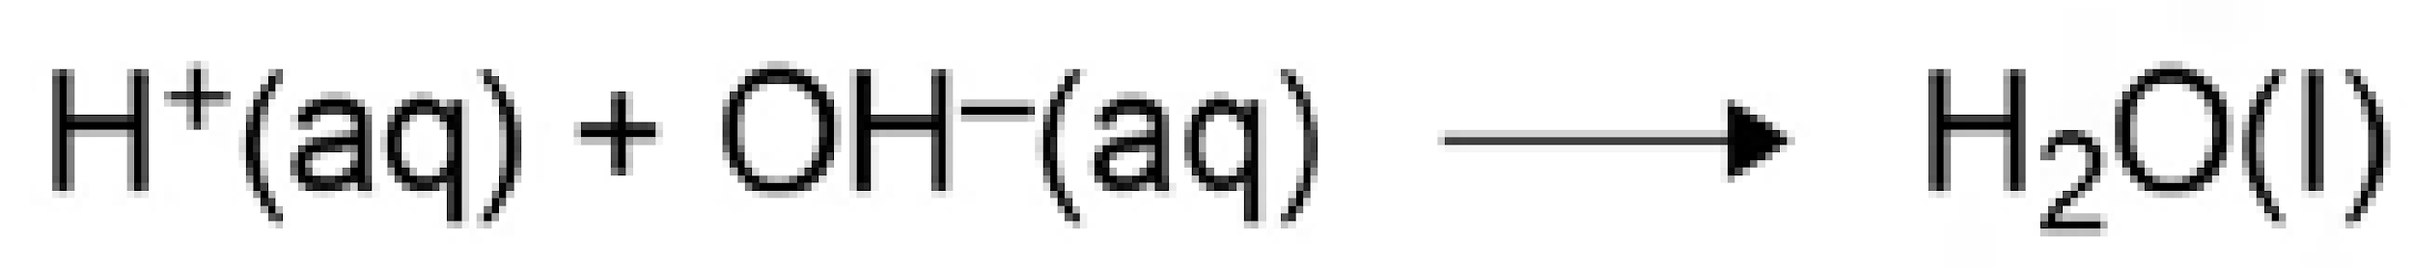
4.4.2 | Higher only  How ionising is a strong acid in aqueous solution? | A strong acid is completely ionised in aqueous solution
4.4.2 | Higher only  Give some examples of strong acids | Examples of strong acids are hydrochloric, nitric and sulfuric acids
4.4.2 | Higher only  How ionising is a weak acid in aqueous solution? | A weak acid is only partially ionised in aqueous solution
4.4.2 | Higher only  Give some examples of weak acids | Examples of weak acids are ethanoic, citric and carbonic acids
4.4.2 | Higher only  What is the relationship between concentration of acid and pH | For a given concentration of aqueous solutions, the stronger an acid, the lower the pH
4.4.2 | Higher only  As pH decreases by a single unit, what happens to the hydrogen ion concentration in the solution? | As the pH decreases by one unit, the hydrogen ion concentration of the solution increases by a factor of 10
Specification 4.4.3 | What happens to the ions in an ionic compound when melted or dissolved? | The ions are free to move about within the liquid or solution
Specification 4.4.3 | What is special about a molten or liquid ionic compound? | These liquids and solutions are able to conduct electricity
Specification 4.4.3 | What is the name of a molten or ionic liquid? | They are called electrolytes
Specification 4.4.3 | What happens when you pass electric current through an electrolyte? | Passing an electric current through electrolytes causes the ions to move to the electrodes
Specification 4.4.3 | What direction do positively charged ions move? | Positively charged ions move to the negative  electrode (the cathode)
Specification 4.4.3 | What direction do negatively charged ions move? | Negatively charged ions move to the positive electrode (the anode)
Specification 4.4.3 | What happens to ions once they arrive at an electrode? | Ions are discharged at the electrodes producing elements
Specification 4.4.3 | What is the name of the process where electric current is passed through an electrolyte? | This process is called electrolysis
Specification 4.4.3 | What happens when a simple ionic compound is electrolysed such as lead bromide in the molten state? | The metal (lead) is produced at the cathode and the non-metal (bromine) is produced at the anode
Specification 4.4.3 | Why do we use electrolyse during metal extraction? | Metals can be extracted from molten compounds using electrolysis
Specification 4.4.3 | Why is electrolysis used for only some metals? | Electrolysis is used if the metal is too reactive to be extracted by reduction with carbon or if the metal reacts with carbon
Specification 4.4.3 | What is the disadvantage in using electrolysis for metal extraction? | Large amounts of energy are used in the extraction process to melt the compounds and to produce the electrical current
Specification 4.4.3 | How is aluminium manufactured? | By the electrolysis of a molten mixture of aluminium oxide and cryolite using carbon as the positive electrode (anode)
Specification 4.4.3 | What effects how ions are discharged during electrolysis? | Relative reactivity of the elements involved
Specification 4.4.3 | What is produced at the negative electrode if the metal is more reactive than hydrogen? | At the negative electrode (cathode), hydrogen is produced if the metal is more reactive than hydrogen
Specification 4.4.3 | What forms at the positive electrode unless the solution contains halide ions? | At the positive electrode (anode), oxygen is produced unless the solution contains halide ions when the halogen is produced
Specification 4.4.3 | Higher only  What type of reaction happens at the cathode when positive ions gain electrons? | During electrolysis, at the cathode (negative electrode), positively charged ions gain electrons and so the reactions are reductions (OIL RIG)
Specification 4.4.3 | Higher only  What type of reaction happens at the anode when a negative ion loses electrons? | At the anode (positive electrode), negatively charged ions lose electrons and so the reactions are oxidations (OIL RIG)
C5 Chemical energy (paper 1) – QUICK QUIZ QUESTIONS
Spec | QUESTION | ANSWER | TICK
Specification 4.5.1 | What gets conserved in a chemical reaction? | Energy is conserved in chemical reactions
Specification 4.5.1 | What is the conservation of energy? | The amount of energy in the universe at the end of a chemical reaction is the same as before the reaction takes place
Specification 4.5.1 | If energy is transferred to the surroundings, do the reactants have more or less energy than the products? | The product molecules must have less energy than the reactants, by the amount transferred
Specification 4.5.1 | What is an exothermic reaction? | Transfers energy to the surroundings so the temperature of the surroundings increases
Specification 4.5.1 | Give some examples of exothermic reactions | - Combustion  - many oxidation reactions  - neutralisation
Specification 4.5.1 | Name an everyday example of where you would find an exothermic reaction | Self-heating cans and hand warmers
Specification 4.5.1 | What is an endothermic reaction? | Takes in energy from the surroundings so the temperature of the surroundings decreases
Specification 4.5.1 | Name an endothermic reaction | The reaction of citric acid and sodium hydrogen carbonate
Specification 4.5.1 | Where might we use endothermic reactions in everyday life? | Some sports injury packs are based on endothermic reactions
Specification 4.5.1 | When can chemical reactions take place? | Chemical reactions can occur only when reacting particles collide with each other and with sufficient energy
Specification 4.5.1 | What is the name of the minimum amount of energy that particles must have to react? | The activation energy
Specification 4.5.1 | How might a chemist show energies used in a reaction? | Reaction profiles can be used to show the relative energies of reactants and products, the activation energy and the overall energy change of a reaction
Specification 4.5.1 | Higher only - How does the energy relate to bonding in reactants and products? | • energy must be supplied to break bonds in the reactants  • energy is released when bonds in the products are formed
Specification 4.5.1 | Higher only - How can you calculate the energy needed to break bonds and releases from bonds? | The energy needed to break bonds and the energy released when bonds are formed can be calculated from bond energies
Specification 4.5.1 | Higher only - What is the overall energy change in a reaction? | The difference between the sum of the energy needed to break bonds in the reactants and the sum of the energy released when bonds in the products
Specification 4.5.1 | Higher only- Is the energy released in an exothermic reaction greater or less than the energy needed to break existing bonds? | The energy released from forming new bonds is greater than the energy needed to break existing bonds
Specification 4.5.1 | Higher only - Is the energy in an endothermic reaction greater than or less than the energy needed to form new bonds? | The energy needed to break existing bonds is greater than the energy released from forming new bonds

