JOG Science Faculty Revision Support

Physics PAPER 1 Quick Quiz Sheets

CONTENT
- (P1) Energy

- (P2) Electricity

- (P3) The particle model of matter

- (P4) Atomic structure

Parents and guardians frequently inquire about how they can support their children in preparing for their science exams. Quick quiz sheets offer an opportunity for parental involvement in the revision journey. These sheets contain crucial information essential for success in the GCSE science exams, allowing families to memorise important facts together. Additionally, personalised learning checklists are provided for each module, enabling students to track their progress effectively.

Given on candidate sheet |  | Module | PAPER
Kinetic Energy | E_{k} = ½ x m x v² | P1 | PHYSICS PAPER 1
Gravitational potential | E_{p} = m x g x h | P1 | PHYSICS PAPER 1
Power 1 | P = E ÷ t | P1 | PHYSICS PAPER 1
Power 2 | P = W ÷ t | P1 | PHYSICS PAPER 1
Efficiency 1 | Efficiency = useful power output ÷ total power in | P1 | PHYSICS PAPER 1
Efficiency 2 | Efficiency = useful energy output ÷ total energy in | P1 | PHYSICS PAPER 1
Charge | Q = I x t | P2 | PHYSICS PAPER 1
Voltage | V = I x R | P2 | PHYSICS PAPER 1
Power 3 | P = V x I | P2 | PHYSICS PAPER 1
Power 4 | P = I² x R | P2 | PHYSICS PAPER 1
Energy (HIGHER ONLY) | E = Q x V | P2 | PHYSICS PAPER 1
Density | p = m ÷ vol | P3 | PHYSICS PAPER 1
Elastic energy | E_{e} = ½ x k x e² | P1 | PHYSICS PAPER 1
Specific heat capacity | ΔE= m x c x ϑ | P1 | PHYSICS PAPER 1
Latent heat | E = m x L | P3 | PHYSICS PAPER 1
Weight | W = m x g | P5 | PHYSICS PAPER 2
Work done | W = F x s | P5 | PHYSICS PAPER 2
Force on a spring | F = k x e | P5 | PHYSICS PAPER 2
Acceleration | a = Δv ÷ t | P5 | PHYSICS PAPER 2
Force on a mass | F = m x a | P5 | PHYSICS PAPER 2
Momentum | P = m x v | P5 | PHYSICS PAPER 2
Speed 1 | v = s ÷ t | P5 | PHYSICS PAPER 2
Wave equation | v = f x λ | P6 | PHYSICS PAPER 2
Acceleration | v²- u² = 2as | P5 | PHYSICS PAPER 2
Period | T= 1 ÷f | P6 | PHYSICS PAPER 2
Force on a wire in a mag field | F = B x I x l | P7 | PHYSICS PAPER 2

P1 ENERGY – QUICK QUIZ QUESTIONS
Spec | QUESTION | ANSWER | TICK
Specification 4.1.1 | What is a ‘system’ in physics? | A system is an object or group of objects
Specification 4.1.1 | When a system ‘changes’ what happens to the energy in that system? | There are changes in the way the energy is stored
Specification 4.1.1 | What is the equation for kinetic energy? | kinetic energy = 05 × mass × speed²  $$E_{k}= \frac{1}{2}mv^{2}$$
Specification 4.1.1 | What is the unit for kinetic energy? | (E_{K}) Joules, J
Specification 4.1.1 | What is the unit for mass? | (m), in kilograms, kg
Specification 4.1.1 | What is the unit for velocity? | speed (v) in metres per second, m/s
Specification 4.1.1 | What is the equation for finding elastic potential energy? | elastic potential energy = 05 × spring constant × extension²  $$E_{e}= \frac{1}{2} Ke^{2}$$
Specification 4.1.1 | What is the unit for stretched energy in a spring? | Elastic potential energy, E_{e} , in joules, J
Specification 4.1.1 | What is the unit for the spring constant? | Spring constant, (k) in Newton’s per metre, N/m
Specification 4.1.1 | What is the unit for extension? | Extension (e) is measured in metres, m
Specification 4.1.1 | What is the equation for finding the gravitational potential energy? | GPE = mass × gravitational field strength × height  $$E_{gpe}=mg∆h$$
Specification 4.1.1 | What are the units of gravitational potential energy? | Gravitational potential energy, (E_{p}), in joules, J
Specification 4.1.1 | What are the units of mass? | Mass (m), in kilograms, kg
Specification 4.1.1 | What are the units for gravitational field strength? | Gravitational field strength, g, in Newton’s per kilogram, N/kg
Specification 4.1.1 | What is the special value for gravitational field strength? | 10 N/kg
Specification 4.1.1 | What are the units for height? | Height (h), in metres, m
Specification 4.1.1 | What is the equation for change in thermal energy for a material? | Change in thermal energy = mass × specific heat capacity × temperature change  $$∆E=mc∆θ$$
Specification 4.1.1 | What are the units and symbol for ‘change in thermal energy’? | Change in thermal energy, ∆E, in joules, J
Specification 4.1.1 | What are the units for mass? | Mass, m, in kilograms, kg
Specification 4.1.1 | What are the units for specific heat capacity? | Specific heat capacity, c, in joules per kilogram per degree Celsius, J/kg °C
Specification 4.1.1 | What are the units for change in temperature? | Temperature change, ∆θ, in degrees Celsius, °C
Specification 4.1.1 | What is the specific heat capacity of a material? | The amount of energy required to raise the temperature of one kilogram of the substance by one degree
Specification 4.1.1 | Define the term ‘power’ | Power is defined as the rate at which energy is transferred (or the rate at which work is done)
Specification 4.1.1 | What is the equation for calculating power? | Power = energy transferred ÷ time  $$P= \frac{E}{T}$$
Specification 4.1.1 | What does ‘work done’ mean? | Energy transferred
Specification 4.1.1 | What is the equation for calculating power using ‘work done’ | Power = work done ÷ time  $$P= \frac{Work done}{time}$$
Specification 4.1.1 | What are the units of power? | Power, P, in watts, W
Specification 4.1.1 | What are the units for energy transferred? | Energy transferred, E, in joules, J
Specification 4.1.1 | What are the units for time? | Time, t, in seconds, s
Specification 4.1.1 | What are the units for work done? | Work done, W, in joules, J
Specification 4.1.1 | How much energy is transferred per second in 1 watt? | An energy transfer of 1 joule per second is equal to a power of 1 watt
Specification 4.1.1 | Two electric motors both lift the same weight through the same height but one does it faster than the other. Which does the greater work? | The faster motor
4.1.2 | What is the conservation of energy? | Energy cannot be created or destroyed, only transferred into other forms
4.1.2 | What does a higher thermal conductivity mean for a material? | The higher the thermal conductivity of a material the higher the rate of energy transfer by conduction across the material
4.1.2 | What is the equation for finding the efficiency from the energy it uses? | efficiency = useful output energy ÷ transfer total input energy transfer
4.1.2 | What is the equation for finding the efficiency from the power it uses? | efficiency = useful power output ÷ total power input
4.1.3 | List the main types of energy resources | The main energy resources available for use on Earth include:  - fossil fuels (coal, oil and gas),  - nuclear fuel  - biofuel, wind  - hydro-electricity  - geothermal  - the tides  - the Sun  - Water waves
4.1.3 | What is a renewable energy resource? | A renewable energy resource is one that is being (or can be) replenished as it is used
4.1.3 | What are the uses of typical energy resources? | The uses of energy resources include: transport, electricity generation and heating

P2 Electricity – QUICK QUIZ QUESTIONS
Spec | QUESTION | ANSWER | TICK
Specification 4.2.1 | Draw a circuit symbol for an open switch | 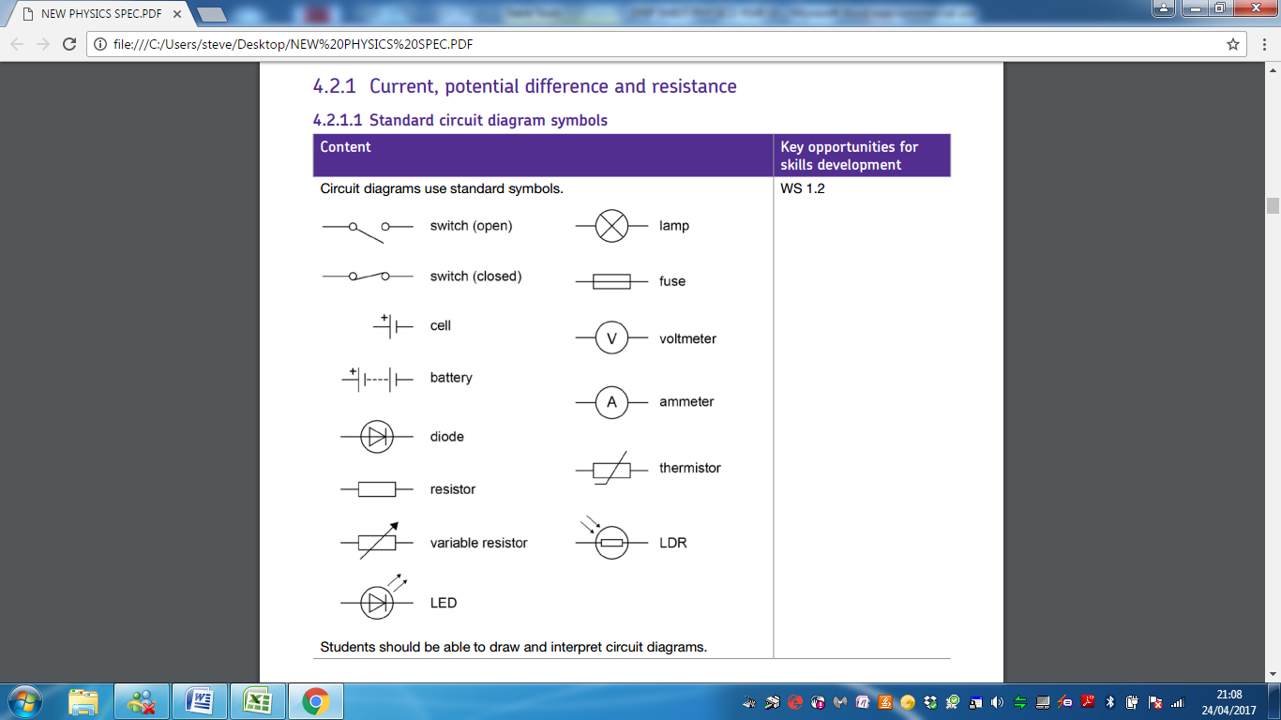
Specification 4.2.1 | Draw a circuit symbol for a closed switch
Specification 4.2.1 | Draw a circuit symbol for a cell
Specification 4.2.1 | Draw a circuit symbol for a battery
Specification 4.2.1 | Draw a circuit symbol for a diode
Specification 4.2.1 | Draw a circuit symbol for a resistor
Specification 4.2.1 | Draw a circuit symbol for a variable resistor
Specification 4.2.1 | Draw a circuit symbol for a lamp
Specification 4.2.1 | Draw a circuit symbol for a fuse
Specification 4.2.1 | Draw a circuit symbol for a voltmeter
Specification 4.2.1 | Draw a circuit symbol for an ammeter
Specification 4.2.1 | Draw a circuit symbol for a thermistor
Specification 4.2.1 | Draw a circuit symbol for an LDR
Specification 4.2.1 | What is electric current? | Electric current is a flow of electrical charge
Specification 4.2.1 | What is the equation for finding charge from current and time? | Charge flow = current × time  $$Q=IT$$
Specification 4.2.1 | What are the units and symbol of charge? | Charge flow, Q, in Coulombs, C
Specification 4.2.1 | What are the units and symbol of current? | Current, I, in amperes, A (amp is acceptable for ampere)
Specification 4.2.1 | What are the units of time? | Time, t, in seconds, s
Specification 4.2.1 | How large is the current at any point in a looped circuit? | A current has the same value at any point in a single closed loop
Specification 4.2.1 | What two things does a current depend on? | The resistance (R) of the component and the potential difference (V) across the component
Specification 4.2.1 | Assuming the potential difference (voltage) is the same across a circuit How will a greater resistance affect the current? | Smaller the current
Specification 4.2.1 | What is another term for voltage (the one used in the exams)? | Potential difference
Specification 4.2.1 | What is Ohm's law? | Potential difference = current × resistance  $$V=IR$$
Specification 4.2.1 | What is the symbol and unit for potential difference (voltage) | Potential difference, V, in volts, V
Specification 4.2.1 | What is the unit and symbol for current? | Current, I, in amperes, A (amp is acceptable for ampere)
Specification 4.2.1 | What is the symbol and unit for resistance? | Resistance, R, in ohms, Ω
Specification 4.2.1 | How would you describe the current through an Ohmic conductor at a constant temperature? | directly proportional
Specification 4.2.1 | Sketch (do not plot or use numbers) the current voltage graph for a resistor | 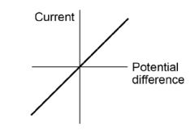
Specification 4.2.1 | How does the resistance across lamps, diodes, thermistors and LDRS behave? | not constant
Specification 4.2.1 | Describe how the resistance through a filament bulb changes | Increases as the temperature of the filament increases
Specification 4.2.1 | Sketch (do not plot or use numbers) the current voltage graph for a bulb | 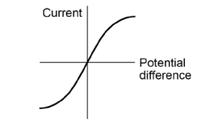
Specification 4.2.1 | Describe how the current through a diode flows | Flows in one direction only The diode has a very high resistance in the reverse direction
Specification 4.2.1 | Sketch (do not plot or use numbers) the current voltage graph for a diode | 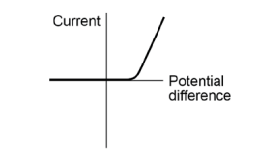
Specification 4.2.1 | What happens to the resistance through a thermistor as the temperature increases? | Decreases as the temperature increases
Specification 4.2.1 | Where might you use a thermistor in everyday life? | When a thermostat is required
Specification 4.2.1 | What happens to the resistance through an LDR (Light Dependent Resistor) as light intensity increases | The resistance of an LDR decreases as light intensity increases
Specification 4.2.1 | Where might you use an LDR in everyday life? | Switching lights on when it gets dark
4.2.2 | What are the two types of circuit? | In series and in parallel
4.2.2 | What is the basic rule about current flowing through components in a series circuit? | There is the same current through each component
4.2.2 | What is the basic rule about potential difference flowing across components in a series circuit? | The total potential difference of the power supply is shared between the components
4.2.2 | What is the rule about resistance when two components are in series? | The total resistance of two components is the sum of the resistance of each component
4.2.2 | What is the equation for working out total resistance between two components (or resistors) | R_{TOTAL} = R₁ + R₂
4.2.2 | What is the unit and symbol for resistance? | Resistance, R, in ohms, Ω
4.2.2 | What is the basic rule about potential difference (voltage) and components in a series circuit? | The potential difference across each component is the same
4.2.2 | What is the basic rule about current in series circuits and current through components? | The total current through the whole circuit is the sum of the currents through the separate components
Specification 4.2.3 | What type of current is supplied to our houses? | Mains electricity is an AC supply
Specification 4.2.3 | What does AC stand for? | Alternating current
Specification 4.2.3 | What is the frequency of UK mains supply? | 50 Hz
Specification 4.2.3 | What is the potential difference (voltage) of UK mains supply? | About 230 V
Specification 4.2.3 | What does DC stand for? | Direct current
Specification 4.2.3 | What supplies DC current? | Batteries
Specification 4.2.3 | How are electrical appliances connected to the mains supply? | Most electrical appliances are connected to the mains using three core cable
Specification 4.2.3 | What are the colours and names of the three types of cables in a three core cable (connected to plugs)? | Live wire – brown  Neutral wire – blue  Earth wire – green and yellow stripes
Specification 4.2.3 | What does the live wire do? | The live wire carries the alternating potential difference from the supply
Specification 4.2.3 | What does the neutral wire do? | The neutral wire completes the circuit
Specification 4.2.3 | What does the Earth wire do? | The earth wire is a safety wire to stop metal appliances becoming ‘live’ and electrocuting people
Specification 4.2.3 | What is the potential difference (voltage) between the live wire and earth pin in a plug? | The potential difference between the live wire and earth (0 V) is about 230 V
Specification 4.2.3 | What is the potential difference (voltage) of the neutral wire? | The neutral wire is at, or close to, earth potential (0 V)
Specification 4.2.3 | What is the potential difference (voltage) of the Earth wire? | The earth wire is at 0 V, it only carries a current if there is a fault
Specification reference 4.2.4 | What is the equation for finding the power of a component in a circuit? | Power = current x potential difference  $$P=IV$$
Specification reference 4.2.4 | Name a second equation for finding the power of a component | Power = current² × resistance  $$P=I^{2}R$$
Specification reference 4.2.4 | What is the symbol and unit for power? | Power, P, in watts, W
Specification reference 4.2.4 | What is the symbol and unit for potential difference? | Potential difference, V, in volts, V
Specification reference 4.2.4 | What is the symbol and unit for current? | Current, I, in amperes, A (amp is acceptable for ampere)
Specification reference 4.2.4 | What is the symbol and unit for resistance? | Resistance, R, in ohms, Ω
Specification reference 4.2.4 | What two things does an appliance depend on for the amount of energy it uses? | - The amount of energy an appliance transfers depends on  - how long the appliance is switched on for and the power of the appliance
Specification reference 4.2.4 | What is electrical work done? | Work is done when charge flows in a circuit
Specification reference 4.2.4 | What is the equation for energy transferred in an electrical circuit? | Energy transferred = power × time  $$E=P ×t$$
Specification reference 4.2.4 | What is the equation for energy transferred in terms of charge and voltage (potential difference) | Energy transferred = charge x potential difference  $$E=Q ×V$$
Specification reference 4.2.4 | What is the symbol and units for energy transferred? | Energy transferred, E, in joules, J
Specification reference 4.2.4 | What is the symbol and units for power? | Power, P, in watts, W
Specification reference 4.2.4 | What is the symbol and units for time? | Time, t, in seconds, s
Specification reference 4.2.4 | What is the symbol and units for charge? | Charge, Q, in Coulombs, C
Specification reference 4.2.4 | What is the symbol and units for potential difference? | Potential difference, V, in volts, V
Specification reference 4.2.4 | What is the national grid made up of? | The National Grid is a system of cables and transformers linking power stations to people’s homes
Specification reference 4.2.4 | What does the national grid do? | Electrical power is transferred from power stations to consumers using the National Grid
Specification reference 4.2.4 | What do step up transformers do? | Step-up transformers are used to increase the potential difference from the power station to the transmission cables
Specification reference 4.2.4 | What do step down transformers do? | Step-down transformers are used to decrease, to a much lower value, the potential difference for domestic use
Specification reference 4.2.4 | Why are transformers used? | So less energy is lost to the surroundings through heating in the cables

P3 the particle model of matter – QUICK QUIZ QUESTIONS
Spec | QUESTION | ANSWER | TICK
4.3.1 | Define the density of an object using an equation | density = volume ÷ mass
4.3.1 | What is the symbol and unit for density? | density, ρ (rho) , in kilograms per metre cubed, kg/m3
4.3.1 | What is the symbol and mass for density? | mass, m, in kilograms, kg
4.3.1 | What is the symbol and unit for volume? | volume, V, in metres cubed,m3
4.3.1 | What two things can the particle model help explain? | • the different states of matter  • differences in density
4.3.1 | Why are chemical changes different to physical changes? | The material recovers its original properties if the change is reversed
Specification 4.3.2 | What is internal energy? | Energy is stored inside a system by the particles (atoms and molecules) that make up the system
Specification 4.3.2 | What types of energy make up internal energy? | Internal energy is the total kinetic energy and potential energy added together
Specification 4.3.2 | How does heating change the energy stored within a system? | Increasing the kinetic energy of the particles that make up the system
Specification 4.3.2 | What does heating up an object do to the temperature of the object? | This either raises the temperature or produces a change of state
Specification 4.3.2 | What does the increase in a system's temperature depend on? | - The mass of the substance heated  - The type of material  - The energy input to the system
Specification 4.3.2 | What is the equation for working out the change in thermal energy for an object | Change in thermal energy = mass × specific heat capacity × temperature change  $$∆E=mc∆θ$$
Specification 4.3.2 | What is the symbol and units for changes in energy? | Change in thermal energy, ∆E, in joules, J
Specification 4.3.2 | What is the symbol and units for mass? | mass, m, in kilograms, kg
Specification 4.3.2 | What is the symbol and units for specific heat capacity? | specific heat capacity, c, in joules per kilogram per degree Celsius, J/kg °C
Specification 4.3.2 | What is the symbol and units for change in temperature? | temperature change, ∆θ, in degrees Celsius, °C
Specification 4.3.2 | What is the specific heat capacity? | The amount of energy required to raise the temperature of one kilogram of the substance by one degree Celsius
Specification 4.3.2 | What is latent heat? | The energy needed for a substance to change state is called latent heat
Specification 4.3.2 | When a change of state occurs what happens to the temperature of the object? | The energy changes (bonds are made or broken) but the temperature remains constant
Specification 4.3.2 | What is specific latent heat? | The specific latent heat of a substance is the amount of energy required to change the state of one kilogram of the substance with no change in temperature
Specification 4.3.2 | What is the equation for calculating the energy change when 1 kg of a substance changes state? | Energy change = mass x specific latent heat  E = m x L
Specification 4.3.2 | What is the symbol and unit for energy? | energy, E, in joules, J
Specification 4.3.2 | What is the unit and symbol for mass? | mass, m, in kilograms, kg
Specification 4.3.2 | What is the unit and symbol for latent heat? | specific latent heat, L, in joules per kilogram, J/kg
Specification 4.3.2 | What is the specific latent heat of fusion? | Specific latent heat of fusion – energy needed to change of state from liquid to solid
Specification 4.3.2 | What is the specific latent heat of vaporisation? | Specific latent heat of vaporisation – energy needed to change of state from liquid to a gas
4.3.3 | How would you describe the motion of particles in a gas? | The molecules of a gas are in constant random motion
4.3.3 | Who is the temperature of a gas related to the kinetic energy of the molecules? | The temperature of the gas is related to the average kinetic energy of the molecules
4.3.3 | If you change the temperature of a gas held at a fixed volume what happens to the pressure of the gas? | Changes the pressure exerted by the gas Hot increases pressure, cold decreases it

P4 Atomic structure
Spec | QUESTION | ANSWER | TICK
Specification 4.4.1 | What is the radius of an atom? | 1 × 10⁻¹⁰ metres
Specification 4.4.1 | In basic terms, describe the structure of an atom | A positively charged nucleus composed of both protons and neutrons surrounded by negatively  charged electrons
Specification 4.4.1 | Where is most of the mass of the atom? | Most of the mass of an atom is concentrated in the nucleus
Specification 4.4.1 | How are electrons in orbit around an atom? | The electrons are arranged at different distances from the nucleus (different energy levels)
Specification 4.4.1 | What happens when an electron absorbs energy? | They jump to a higher energy level
Specification 4.4.1 | What happens when an electron falls to a lower orbit? | The electrons release light
Specification 4.4.1 | How do numbers of electrons and numbers of protons compare in neutral atoms? | Number of electrons is equal to the number of  protons in the nucleus
Specification 4.4.1 | What do all atoms of the same element have in common? | All atoms of a particular element have the same number of protons
Specification 4.4.1 | What is the number of protons in an element called? | Atomic number
Specification 4.4.1 | What are the total number of protons and neutrons called? | Mass number
Specification 4.4.1 | How do atoms get represented? | 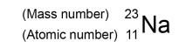
Specification 4.4.1 | What is an isotope? | An element with a different number of neutrons in the nucleus
Specification 4.4.1 | How do positive ions form? | The atom loses an electron
Specification 4.4.1 | What might new scientific evidence lead to? | A scientific model being changed or replaced
Specification 4.4.1 | Before electrons, what did people think atoms looked like? | Atoms were thought to be tiny spheres that could not be divided
Specification 4.4.1 | What model of the atom did the electron lead too? | Plum pudding model of the atom
Specification 4.4.1 | How did the plum pudding model describe the atom? | The atom is a ball of positive charge with negative electrons embedded in it
Specification 4.4.1 | What ideas did the alpha scattering (Rutherford’s scattering) experiment lead to? | The alpha particle scattering experiment led to the  conclusion that:  - the mass of an atom was concentrated at the centre (nucleus)  - that the nucleus was positively charged  - electrons orbit at a distance
Specification 4.4.1 | What did Niels Bohr suggest about the electrons? | He adapted the nuclear model by suggesting that electrons orbit the nucleus at specific distances
Specification 4.4.1 | What particle did James Chadwick discover? | The neutron
Specification 4.4.2 | If an atomic nucleus is unstable, what does this mean? | Radiation is emitted from it to make it more stable
Specification 4.4.2 | What does random, spontaneous decay mean? | The nucleus will decay, it will happy at random and will have happen continuously
Specification 4.4.2 | What does activity mean? | The rate at which a source of unstable nuclei decays
Specification 4.4.2 | What is activity measured in? | Becquerel (Bq)
Specification 4.4.2 | What is count rate? | The number of decays recorded each second by a  detector (eg Geiger-Muller tube)
Specification 4.4.2 | What is an alpha particle? | (α) – this consists of two neutrons and two  protons, it is the same as a helium nucleus
Specification 4.4.2 | What is a beta particle? | (β) – a high speed electron
Specification 4.4.2 | What is a gamma ray? | (γ) – electromagnetic radiation
Specification 4.4.2 | What are nuclear equations? | Ways of representing nuclear reactions
Specification 4.4.2 | Finish this nuclear equation:  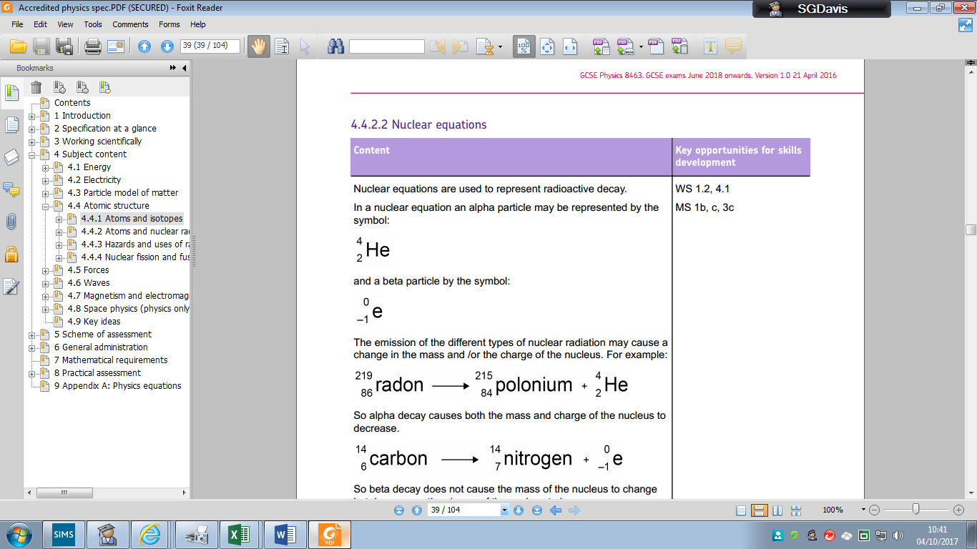
Specification 4.4.2 | Finish this nuclear equation:
Specification 4.4.2 | What does a gamma ray do an element that radioactively decays | A Gamma ray does not cause the mass or the  charge of the nucleus to change
Specification 4.4.2 | What is half life? | The time it takes for the number of nuclei (or activity) of a radioactive isotope in a sample to halve
Specification 4.4.2 | What is radioactive contamination? | The unwanted presence of materials containing radioactive atoms on other materials
Specification 4.4.2 | What is radioactive irradiation? | Irradiation is the process of exposing an object to nuclear radiation  The irradiated object does not become radioactive

