AQA Written Paper – Food Science 2
FOLD OVER TO TEST YOURSELF →→→→
Key Vocabulary | Definition
Caramelisation | Changes of colour and flavour when heating sugar or sugar solution – heating sugar beyond its melting point with the removal of moisture.
Enzymic Browning | Browning of foods due to enzymes in cut fruits and vegetables, this can be slowed down by blanching, dipping into acid e.g. lemon juice, removing air – airtight container / submerging in water.
Oxidation | Changes in food such as colour or flavour change due to exposure of oxygen. Can be prevented by cooking vegetables in small amount of water, cut when needed, serve immediately after cooking, use a lid.
Shortening | Mouthfeel, such as short or crumbly, produced by short gluten strands often made the rubbing in method – shortbread, shortcrust pastry, shortcake.
Emulsification | Mixing liquids that do not normally mix, e.g. oil and water. The use of shaking to disperse the oil / water or the use of lecithin to bind together.
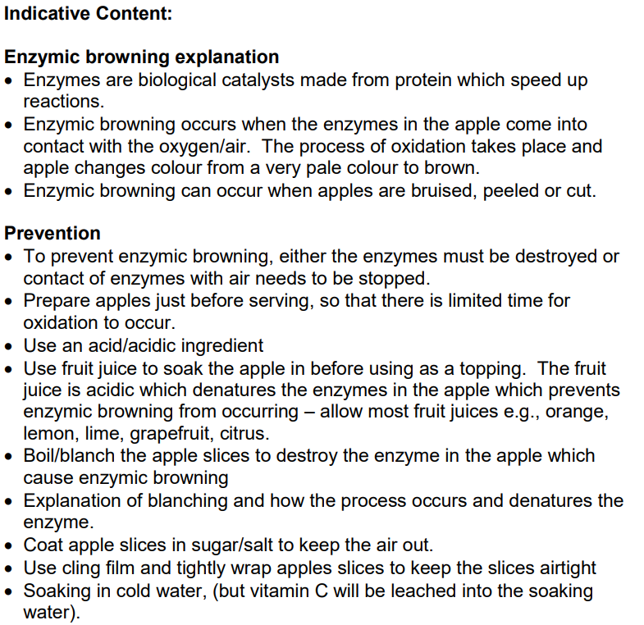
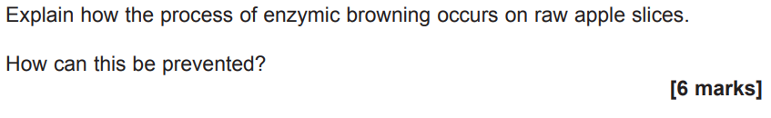
Task | Link to Resource | QR Code
Watch the video and take notes  - Fun Kitchen – Raising Agents | https://www.youtube.com/watch?v=0USi4DbRVVQ
Check your understanding using this quick quiz | https://quizlet.com/4321938/food-science-exam-1-flash-cards/
Practise your exam technique  Heat Transfer –  - Revise  - Test | https://www.bbc.co.uk/bitesize/guides/zr7j382/revision/1

