AQA – Food, Nutrition & Health 2

FOLD OVER TO TEST YOURSELF →→→→
Key Vocabulary | Definition
BMI | Body Mass Index. A measure that adults can use to see if they are a healthy weight for their height. The ideal healthy BMI is between 18.5 and 25.
Rickets | A childhood disease caused by a lack of vitamin D, it causes the bones to soften, which causes bowed legs.
PAL | Physical Activity Level. The energy needed by the body for movement of all types.
Macronutrients | Nutrients that are needed in larger amounts – Fat, Protein, Carbohydrates.
Micronutrients | Nutrients that are needed in smaller amounts – Vitamins (water soluble – B,C, fat soluble – A,D,E,K), Minerals (Calcium, Iron, Fluoride, Sodium, Iodine).

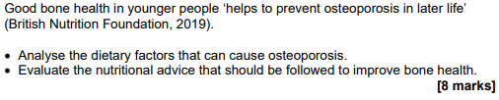

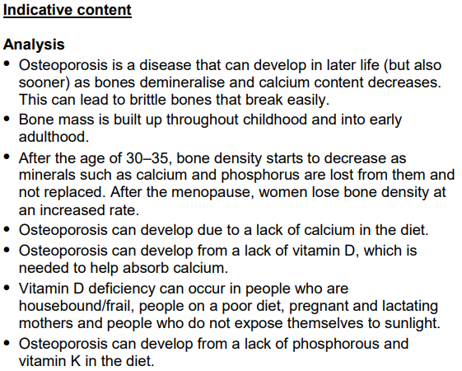

A range of knowledge Organisers can be found here.
https://www.foodafactoflife.org.uk/14-16-years/knowledge-organisers-14-16-years/

Indicative content continues onto the next page.

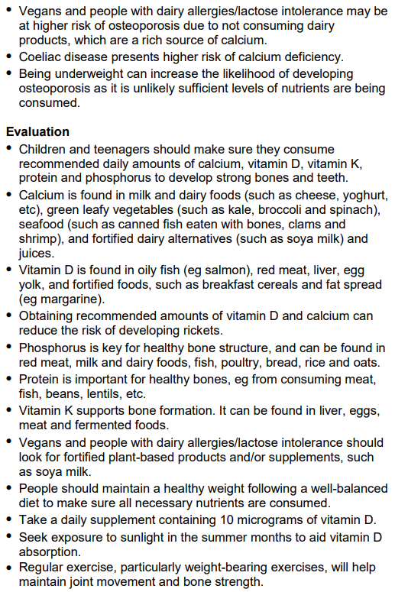

More tasks on the next page.
Task | Link to resource | QR Code
Watch the video and take notes  - Healthier Cooking | https://www.youtube.com/watch?v=fiFi-d0RwKo&list=PLcvEcrsF_9zInjxnoPbjRXHScwzEKTuGr&index=3
Check your understanding using this quick quiz | https://quizlet.com/57358339/nutrition-flash-cards/
Practise your exam technique  Food & Nutrition for Good Health  - Revise  - Video  - Test | https://www.bbc.co.uk/bitesize/guides/z8rqw6f/revision/1

