AQA – FOOD CHOICES 2

FOLD OVER TO TEST YOURSELF →→→→
Key Vocabulary | Definition
Allergy | Condition such as itchy skin or restricted breathing caused by an adverse reaction to something in the environment or food.
Cuisine | A style or method of cooking characteristic of a particular country, region or establishment.
Seasonal Foods | The times of the year when the harvest or the flavour of a given type of food is at its peak. This is usually the time when the item is harvested
Nutrition Labelling | Labels that show which nutrients a food product contains.
Regional | Belonging to one particular geographical region – foods can often be regional, e.g. Cornish pasty, Bakewell tart, cheddar cheese.
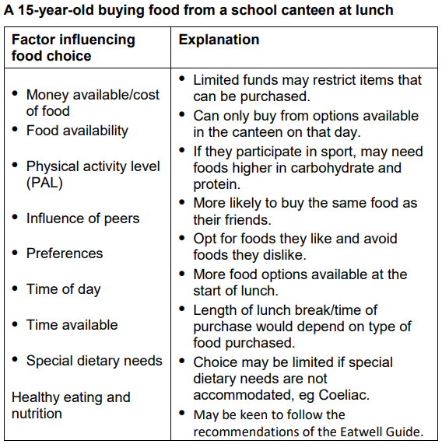
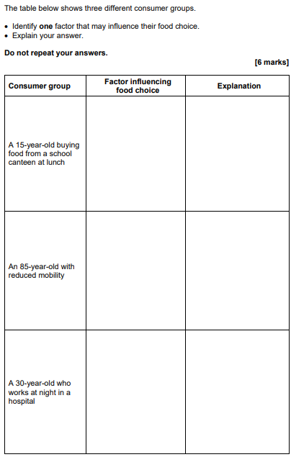

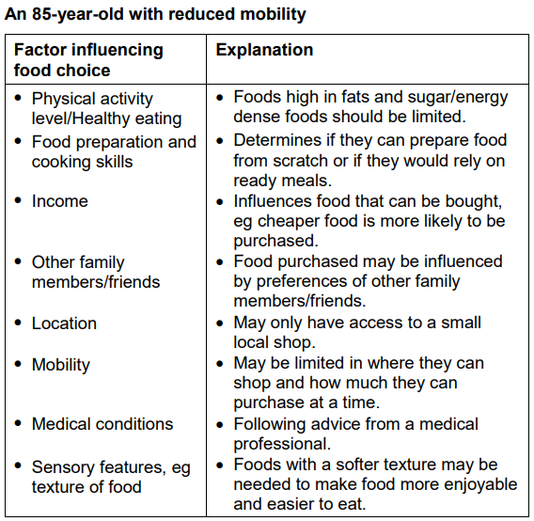

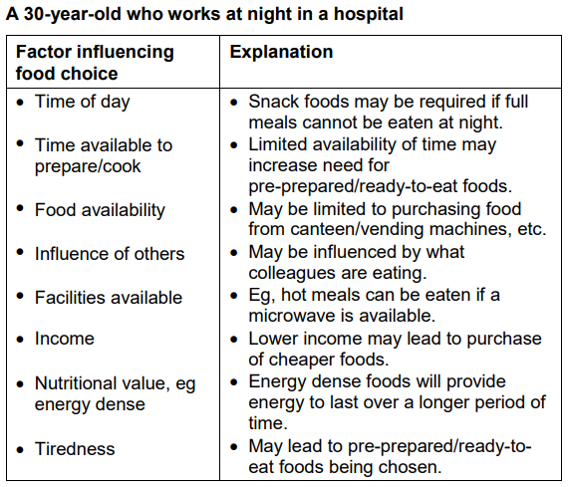
Task | Link to resource | QR Code
Watch the video and take notes  - Food Labelling | https://www.youtube.com/watch?v=OZOIEYQ0axo
Check your understanding using this quick quiz | https://quizlet.com/42117972/food-choices-flash-cards/
Practise your exam technique –  - Revise  - Video  - Test | https://www.bbc.co.uk/bitesize/guides/z7fw7p3/revision/1

A range of knowledge Organisers can be found here.
https://www.foodafactoflife.org.uk/14-16-years/knowledge-organisers-14-16-years/

