AQA – FOOD PROVENANCE 2

FOLD OVER TO TEST YOURSELF →→→→
Indicative Content
Key Vocabulary | Definition
Primary Processing | The conversion of raw materials into food commodities – for example, milling wheat into flour.
Secondary Processing | When the primary product is changed to another product – for example, turning wheat flour into bread.
Food Preservation | Processes that make food more resistant to microorganism growth and slow the oxidation of fats. This slows down decay – canning, drying, sterilisation, pasteurisation, freezing, salting, sugar, acids, smoking, etc.
Chemical Preservation | Adding specific ingredients to foods and food packaging that allows the food to remain safe and fresh – vinegar, sugar, salting, smoking, alcohol, vacuum packing, modified atmosphere packing.
Pasteurisation | HTST – High Temperature Short Time – used mainly for milk, heating it to 71c for 15 seconds, this reduces bacteria down to a safe level to drink.
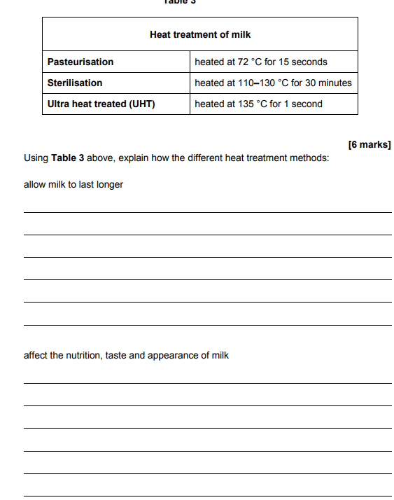

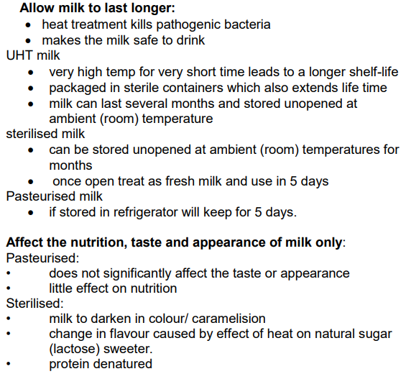

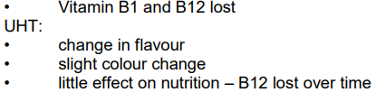

Task | Link to resource
Watch the video and take notes  Wheat processing | https://www.youtube.com/watch?v=y8vLjPctrcU
Check your understanding using this quick quiz | https://quizizz.com/admin/quiz/5f7df1bf037598001b751745/food-processing
Practise your exam technique  - Revise  - Video  - Test | https://www.bbc.co.uk/bitesize/guides/zks8jty/revision/3

