Chemistry

Chemistry may take up the challenge to make forms of matter that have never existed before.

Content

Chemistry involves the learner in enquiring about the nature of substances, or matter, and how they change. This ranges from the human body tissues to ‘star dust’ and from atoms to galaxies.

Learners can understand the importance of Chemistry in our everyday lives, in industry and in changes such as global warming. Chemistry may take up the challenge to make forms of matter that have never existed before.

Special Features
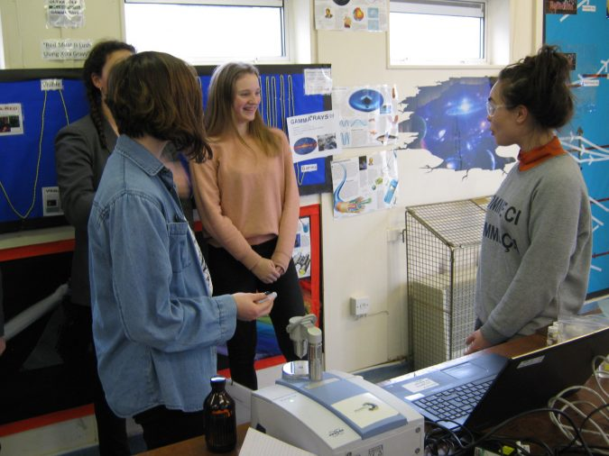
AS and A Level in Chemistry encourages students to:
- appreciate the contributions of Chemistry to society and the responsible use of scientific knowledge and evidence;
- develop essential knowledge and understanding of the concepts of Chemistry, and the skills needed for the use of these in new and changing situations;

- be aware of how advances in information technology and instrumentation are used in Chemistry;
- develop an understanding of the link between theory and experiment;
- bring together knowledge of ways in which different areas of Chemistry relate to each other;
- sustain and develop their enjoyment of, and interest in, Chemistry.

Entry

Please refer to The John of Gaunt Sixth Form entry requirements.

Attendance

AS is a one year course that covers the first four modules, whereas A-Level is a two year course that covers all six modules.

Assessment

Module Title | Mode of Assessment | Brief Outline of Module
1 Development of Practical Skills in Chemistry | AS: 2 x 1.5 hour written exams.  Paper 1: Topics 1 to 4.  70 marks (20 multiple choice). 50% of AS.  Paper 2: Topics 1 to 4.  70 marks. 50% of AS.  A-Level: 3 x written exams.  Paper 1: Topics 1, 2, 3 & 5.  100 marks (including 15 multiple choice).  2 hours 15 minutes.  37% of A-Level.  Paper 2: Topics 1, 2, 4 & 6.  100 marks (including 15 multiple choice).  2 hours 15 minutes.  37% of A-Level.  Paper 3: Topics 1 to 6.  70 marks.  1 hour 30 minutes.  26% of A-Level. | Chemistry is a practical Science and this topic helps to develop the practical skills required for A-Level Chemistry.
2 Foundations in Chemistry |  | This topic expands on the fundamental concepts required from Chemistry; from atomic structure to bonding, and chemical reactions to calculations.
3 Periodic Table & Energy |  | The periodic table is organised in a way that allows us to understand the properties of the 100+ elements. This topic will focus on how and why the table is organised in this way, as well as explaining what happens during a chemical reaction.
4 Core Organic Chemistry |  | Organic Chemistry is the study of carbon and the immense number of chemical compounds that are based on carbon. This topic will look at the chemical and physical properties of alkanes, alkenes, alcohols and halogenoalkanes. As well as introducing the basis of chemical analysis.
5 Physical Chemistry & Transition Elements (A-Level Only) |  | Physical Chemistry encompasses all parts of ‘Non-Organic’ Chemistry. This topic will explain why chemical reactions will only occur at a certain speed and why some reactions go to equilibrium and how to alter its position. It will also look into the concepts of pH, enthalpy and entropy (the measure of disorder). The second half of the topic focuses on explaining the complex Chemistry of the colourful transition elements.
6 Organic Chemistry & Analysis |  | Building on the Organic Chemistry covered in topic 4, this will look at more complex carbon based compounds from the ring structures based on Benzene to the aromatic esters and the pungent amines. It also looks into the Chemistry of amino acids, the synthesis of chemicals from feedstocks used in many chemical industries including drug manufacture and a deeper exploration into the analysis of compounds.
Practical Endorsement (A-Level Only) | Internal assessment of required practicals linked to the course content, which are carried out and written as lab reports. | The practical endorsement is a separate certificate that demonstrates a competency in the practical skills developed during the course. It does not contribute towards the final grade.

Moving on

This course aims to develop an interest in further study and careers in Chemistry as well as the wider field where the ability to think logically, understand complex ideas and apply them to the real world is necessary. Whether you want to pursue a career in Science, Education or a host of other fields, Chemistry will enable you to show you have the skills, knowledge and understanding required.

